GovHack Data – Department of Employment
Employment services are the Australian Government’s way of helping more Australians’ get into work. Job seekers generally have to participate in employment services when they get an income support payment, such as Newstart Allowance, Youth Allowance (other), or Parenting Payment.
This involves attending an appointment with an Employment Service Provider – businesses that are contracted by the Department of Employment to deliver employment services. Employment Service Providers (Providers) are expected to help job seekers get closer to obtaining work. Once a job seeker is being assisted by a Provider, they are on that Providers’ ‘caseload’.
Job Services Australia
Job Services Australia (JSA) was the Australian Government’s employment service between 1 July 2009 to 30 June 2015.
In most cases Job Seekers connected with a JSA provider following a referral by Centrelink. Job seekers were able to choose their provider.

Eligibility

The key group of participants in JSA were fully eligible participants. Fully eligible participants were:
- those in receipt of an eligible income support payment (such as Newstart Allowance, Youth Allowance (other), Disability Support Payment and Parenting Payment);
- young people (aged 15 to 21); and
- vulnerable youth who were full time students aged 15-21 years (who were eligible for Stream 4 services – see below).

Streams
Under JSA, a job seeker was be allocated to one of four streams, based on their assessed level of disadvantage.
- Stream 1 job seekers were the most job ready, with no barriers to employment.
- Stream 2 job seekers were job seekers with some barriers to employment or level of disadvantage.
- Stream 3 job seekers had a greater level of difficulty gaining and maintaining employment, with some personal barriers.
- Stream 4 job seekers were the most disadvantaged job seekers, with multiple barriers to employment (such as drug addiction, homelessness etc).
The Stream in which a job seeker is placed in was determined by the job seeker’s level of disadvantage as assessed by the Job Seeker Classification Instrument (JSCI) and, where needed, an ESAt or Job Capacity Assessment. The JSCI relied largely on information disclosed by the job seeker along with information gathered by Centrelink to identify the likelihood of a job seeker remaining unemployed without assistance. Further information on the JSCI is available from the mentors.

Employment Pathway Fund
Providers had access to an Employment Pathway Fund (EPF) which they could use to purchase vocational and non-vocational goods and services to assist the job seeker in obtaining employment. The EPF was a flexible pool of funds that could be drawn down by providers to help job seekers obtain employment. Providers received an EPF credit for each eligible job seeker commensurate with their level of disadvantage. Examples of the goods and services that could be purchased through the EPF included: training, travel assistance, work clothing, uniforms and safety equipment, wage subsidies and work trials, work tools, tickets and licences, etc.
When was a job seeker in service and on the caseload?
A job seeker was considered to be receiving services (and on the caseload) in JSA from the time they commenced with a provider until they exited service. However, there may be times when service is suspended because, for example, the job seeker is exempted from participation for a period (due to say temporary medical illness).

Payments to Providers

The payment model includes Service Fees, Placement Fees and Outcome Fees

Service Fees

Service fees are paid for the administration functions carried out by providers in delivering employment services

Job placement fees

Job placement fees were paid when a job seeker completes a minimum period of paid work. This was 50 hours of paid work in a Placement within 10 consecutive working days for a job seeker with full work capacity

Outcome fees

Outcome fees were be paid to providers for job seekers in Streams 2 to 4 who remained in employment for a minimum of 13 weeks or remained in education for at least one semester of a course of two or more semesters.

The Outcome Fees were based on the job seeker’s Stream and length of unemployment. Outcome payments were higher for disadvantaged job seeker sin higher streams.

More details on the programme parameters and fees are available from Department of Employment mentors.
Remote job seekers
Job Services Austrlaia serviced job seekers in remote locaitons up until 30 June 2013. From 1 July 2013 the Government introduced the Remote Jobs and Communities Programme to deliver employment services to job seekers in remote Australia. The Commnity Development Programme replaced the Remote Jobs and Community Programme on 1 July 2015..
The Data Sets
The datasets provided detail the JSA youth caseload (job seekers aged 15-24) for various regions across Australia, broken down by various demographics.
There is one workbook for each financial year for the span of Job Services Australia, each with one worksheet for each month of the year.
The data in each worksheet is as at the last day of each month.
It is important to note that any counts in the dataset of less than 20 have been suppressed, and appear as blank (or empty cells). This was done to ensure no individual job seeker can be identified.
To ensure suppressed figures can’t be calculated, at least one other additive demographic may have been suppressed (for example, if the Female demographic has been suppressed, the Male demographic may be suppressed to ensure the female count can’t be derived).
GovHack Data Dictionary – Caseload Data – (GovHack_YY_YY.xls):
LMR_Name – Labour Market Region. Australia is divided in to Labour Market Regions also known as Labour Force Regions or Statistical Areas Level 4 (for ABS purposes). There are used to create a variety of regional level data. Maps of LMRs are available at Attachment A.
ESA_Name – Employment Services Area. Australia is further divided into Employment Services Areas for the purpose of employment services. They are small regions located all over the country that are expected to match small area labour markets. Under JSA, providers were contracted to deliver services to eligible job seekers in an ESA. Maps of LMRs and ESAs together with SLAs that make up these regions are available at Attachment A.
Male- Number of Males on caseload at the last day of the month.
Female- Number of Females on caseload at the last day of the month.
Undefined- Number of job seekers who do not identify, or have not been identified, as Male or Female, on caseload at the last day of the month.
Aged_15_20- Number of job seekers aged between 15 and 20 years (inclusive) on the caseload at the last day of the month. The age of the job seekers has been calculated as at the last day of the month.
Aged_21_24- Number of job seekers aged between 21 and 24 years (inclusive) on the caseload at the last day of the month. The age of the job seekers has been calculated as at the last day of the month.
Stream_1- Number of job seekers in Stream 1 on the caseload at the last day of the month.
Stream_2- Number of job seekers in Stream 2 on the caseload at the last day of the month.
Stream_3- Number of job seekers in Stream 3 on the caseload at the last day of the month.
Stream_4- Number of job seekers in Stream 4 on the caseload at the last day of the month.
Indigenous- Number of job seekers who identify as Indigenous and who are on the caseload on the last day of the month.
Refugee- Number of refugee’s on the caseload at the last day of the month.
Remote- Number of job seekers identified as living in remote areas of Australia on the last day of the month.
Homeless- Number of job seekers identified as homeless as at the last day of the month. This may be living on the street or no fixed address (eg. couch surfing).
Disability- Number of job seekers who identify as having a disability as at the last day of the month.
CALD- Number of job seekers identified as culturally and Linguistically Diverse at the last day of the month.
Sole parent- Number of job seekers who are single parents, on the caseload, as at the last day of the month.
Parent- Number of job seekers who are partnered parents, on the caseload, as at the last day of the month.
Edu_Lvl_none- Number of job seekers with no completed level of education, on the caseload, as at the last day of the month.
EDU_LVL_TRADE_OR_TAFE- Number of job seekers who have a trade or tafe qualification (ie. CIT qualifications, diplomas, apprenticeships etc) on the caseload, as at the last day of the month.
EDU_LVL_UNI- Number of job seekers who have a university level qualification and above (ie, Bachelor’s degree, Post-Graduate degree etc.) on the caseload, as at the last day of the month.
EDU_LVL_UNKNOWN- Number of job seekers who have an unknown level of education, on the caseload, as at the last day of the month.
EDU_LVL_YR_1_to_9- Number of job seekers with only Year 1 to Year 9 education completed, on the caseload, as at the last day of the month.
EDU_LVL_YR_10_13- Number of job seekers with only Year 10 to year 13 education completed, on the caseload, as the last day of the month.
Non_Allowee- Number of job seekers who are not on any allowance (income support) on the caseload, as at the last day of the month.
Newstart- Number of job seekers who are on Newstart allowance on the caseload, as at the last day of the month.
Youth_Allowance- Number of job seekers who are on Youth Allowance on the caseload, as at the last day of the month.
Disability_SP- Number of job seekers who are on Disability Support Pension allowance on the caseload, as at the last day of the month.
Carers_Allow- Number of job seekers who are on Carers allowance on the caseload, as at the last day of the month.
Parenting_Single- Number of job seekers who are on Parenting payments – single parents allowance on the caseload, as at the last day of the month.
Parenting_Partnered- Number of job seekers who are on Parenting payments - partnered allowance on the caseload, as at the last day of the month.
Other_Allow- Number of job seekers who are on another allowance type on the caseload, as at the last day of the month.
UE_less_than_12 – Number of job seekers who are unemployed for less than 12 months.
UE_12_to_24- Number of job seekers who are unemployed from 12 to less than 24 months, as at the last day of the month.
UE_24_and_more- Number of job seekers who are unemployed from 24 or more months, as at the last day on the caseload.
UE_DUR_MISSING- Number of job seekers who have not disclosed their length of unemployment, as at the last day of the month.
Total_Caseload- Total number of job seekers on the caseload, as at the last day of the month.

GovHack Data Dictionary – Outcomes.xlsx:
LMR_Name – Labour Market Region. Australia is divided in to Labour Market Regions also known as Labour Force Regions or Statistical Areas Level 4 (for ABS purposes). There are used to create a variety of regional level data. Maps of LMRs are at Attachment A.
ESA_Name – Employment Services Area. Australia is further divided into Employment Services Areas for the purpose of employment services. They are small regions located all over the country that are expected to match small area labour markets. Under JSA, providers were contracted to deliver services to eligible job seekers in an ESA. Maps of LMRs and ESAs together with SLAs that make up these regions are at Attachment A.
Outcome_13wk – Number of job seekers who achieved a 13 week paid outcome that month.
Outcome_26wk – Number of job seekers who achieved a 26 week paid outcome that month.
Paid_Placements- Number of job seekers who were placed into a job that attracted a job placement fee in that month.
Male- Number of Males who achieved a paid outcome that month.
Female- Number of Females who achieved a paid outcome that month.
Aged_15_20- Number of job seekers aged between 15 and 20 years (inclusive) who achieved an outcome that month. The age of the job seeker has been calculated as at the last day of the month.
Aged_21_24- Number of job seekers aged between 21 and 24 years (inclusive) who achieved an outcome that month. The age of the job seeker has been calculated as at the last day of the month.
Indigenous- Number of job seekers who identify as Indigenous who are who achieved a paid outcome that month.
Refugee- Number of refugees who achieved a paid outcome that month.
Remote- Number of job seekers identified as living in remote areas of Australia who achieved a paid outcome that month.
Homeless- Number of job seekers identified as homeless who achieved a paid outcome that month. This may be living on the street or no fixed address (ie. couch surfing).
Disability- Number of job seekers who identify as having a disability who achieved a paid outcome that month.
CALD- Number of job seekers identified as culturally and Linguistically Diverse who achieved a paid outcome that month.
Sole parent- Number of job seekers who are single parents, who achieved a paid outcome, that month.
Parent- Number of job seekers who are partnered parents, who achieved a paid outcome that month.
Edu_Lvl_none- Number of job seekers with no completed level of education, who achieved a paid outcome, that month.
EDU_LVL_TRADE_OR_TAFE- Number of job seekers who have a trade or tafe qualification (ie. CIT qualifications, diplomas, apprenticeships etc) who achieved a paid outcome, that month.
EDU_LVL_UNI- Number of job seekers who have a university level qualification and above (ie, Bachelor’s degree, Post-Graduate degree etc.) who achieved a paid outcome, that month.
EDU_LVL_UNKNOWN- Number of job seekers who have an unknown level of education, who achieved a paid outcome, that month.
EDU_LVL_YR_1_to_9- Number of job seekers with only Year 1 to Year 9 education completed, who achieved a paid outcome, that month.
EDU_LVL_YR_10_13- Number of job seekers with only Year 10 to year 13 education completed, who achieved a paid outcome, that month.
Non_Allowee- Number of job seekers who are not on any allowance (income support) who achieved a paid outcome, that month.
Newstart- Number of job seekers who are on Newstart allowance on the caseload, who achieved a paid outcome that month.
Youth_Allowance- Number of job seekers who are on Youth Allowance who achieved a paid outcome, that month.
Disability_SP- Number of job seekers who are on Disability Support Pension allowance who achieved a paid outcome, that month.
Carers_Allow- Number of job seekers who are on Carers allowance who achieved a paid outcome, that month.
Parenting_Single- Number of job seekers who are on Parenting payments – single parents allowance who achieved a paid outcome, that month.
Parenting_Partnered- Number of job seekers who are on Parenting payments - partnered allowance who achieved a paid outcome, that month.
Other_Allow- Number of job seekers who are on some other allowance type who achieved a paid outcome, that month.
UE_less_than_12 – Number of job seekers who are unemployed for less than 12 months who achieved a paid outcome that month.
UE_12_to_24- Number of job seekers who are unemployed from 12 to less than 24 months, who achieved a paid outcome that month.
UE_24_and_more- Number of job seekers who are unemployed from 24 or more months, who achieved a paid outcome that month.
UE_DUR_MISSING- Number of job seekers who have not disclosed their length of unemployment, who achieved a paid outcome that month.
There are also a number of job placements by industry. The variables titles and the industry descriptions are here:
Variable Name | Industry Type Description
Accom_and_food_serv | Accommodation and food services
Admin_and_Support_serv | Administrative and support services
Ag_forestry_fishing | Agriculture, Forestry and Fishing
Arts_and_rec | Arts and recreation services
Construction | Construction
Edu_and_training | Education and Training
Elec_gas_water_waste | Electricty, Gas, Water, Waste Services
Finance_insurance | Financial and Insurance Services
Health_care_social | Heralth Care and Social Assistance
Info_media_telecom | Information Media and Telecommunications
Manufacturing | Manufacturing
Mining | Mining
None | None
Other | Other Services
Professional_Sc_tech | Professional, Scientific, Technical Services
Public_admin_safe | Public Administration and Safety
Elec_gas_water_waste | Rental, Hiring and Real Estate Services
Retail | Retail Trade
Transport_Post | Transport, Postal and Warehousing
Wholesale_Trade | Wholesale Trade

Appendix A: Labour Market Regions and Employment Services Areas

The first column lists the Employment Service Areas (ESAs) in place for Jobs Services Australia.
The second column lists the Australian Bureau of Statistics, Statistical Local Areas (SLAs) that comprise an ESA. More information on SLAs can be found at abs.gov.au
The following abbreviations are used in this Appendix:
Bal Balance
C City
S Shire
T Town
SSD Statistical Subdivision
Unincorp. Unincorporated
LABOUR MARKET REGION—SYDNEY
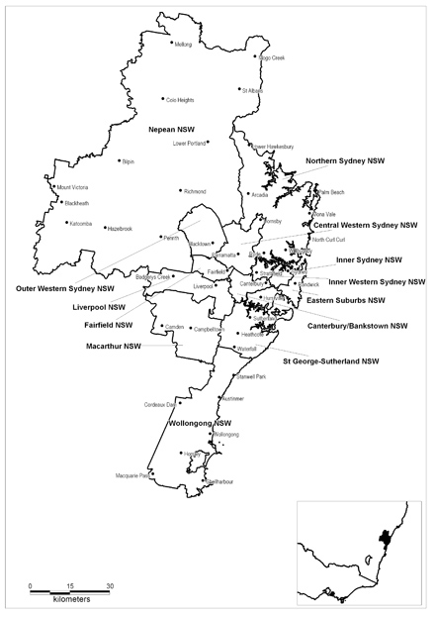
LABOUR MARKET REGION—SYDNEY
Employment Service Area | Statistical Local Area
Canterbury/ Bankstown NSW | Bankstown—North-East, Bankstown—North-West, Bankstown—South, Canterbury
Central Western Sydney NSW | Auburn, Baulkham Hills—Central, Baulkham Hills—South, Holroyd, Hornsby—South, Parramatta—Inner, Parramatta—North-East, Parramatta—North-West, Parramatta—South
Eastern Suburbs NSW | Botany Bay, Randwick, Waverley, Woollahra
Fairfield NSW | Fairfield—East, Fairfield—West
Inner Sydney NSW | Leichhardt, Lord Howe Island, Marrickville, Sydney—East, Sydney—Inner, Sydney—South, Sydney—West
Inner Western Sydney NSW | Ashfield, Burwood, Canada Bay—Concord, Canada Bay—Drummoyne, Strathfield
Liverpool NSW | Liverpool—East, Liverpool—West
Macarthur NSW | Camden, Campbelltown—North, Campbelltown—South
Nepean NSW | Baulkham Hills—North, Blue Mountains, Hawkesbury, Penrith—East, Penrith—West
Northern Sydney NSW | Hornsby—North, Hunter’s Hill, Ku-ring-gai, Lane Cove, Manly, Mosman, North Sydney, Pittwater, Ryde, Warringah, Willoughby
Outer Western Sydney NSW | Blacktown—North, Blacktown—South-East, Blacktown—South-West
St George- Sutherland NSW | Hurstville, Kogarah, Rockdale, Sutherland Shire—East, Sutherland Shire—West
Wollongong NSW | Shellharbour, Wollongong—Inner, Wollongong Bal

LABOUR MARKET REGION—HUNTER
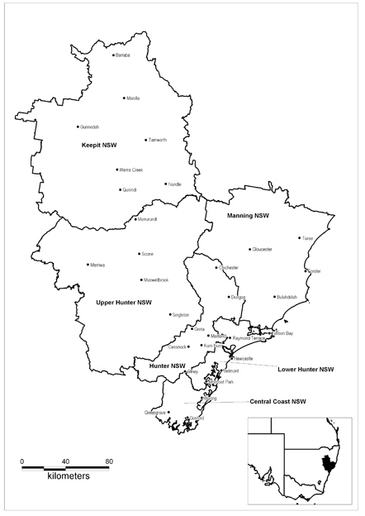
LABOUR MARKET REGION—HUNTER
Employment Service Area | Statistical Local Area
Central Coast NSW | Gosford—East, Gosford—West, Wyong—North-East, Wyong—South and West
Hunter NSW | Cessnock, Dungog, Maitland
Keepit NSW | Gunnedah, Liverpool Plains, Tamworth Regional—Part A, Tamworth Regional—Part B
Lower Hunter NSW | Lake Macquarie—East, Lake Macquarie—North, Lake Macquarie—West, Newcastle—Inner City, Newcastle—Outer West, Newcastle—Throsby, Port Stephens
Manning NSW | Gloucester, Great Lakes, Greater Taree
Upper Hunter NSW | Muswellbrook, Singleton, Upper Hunter Shire

LABOUR MARKET REGION—NORTHERN NEW SOUTH WALES
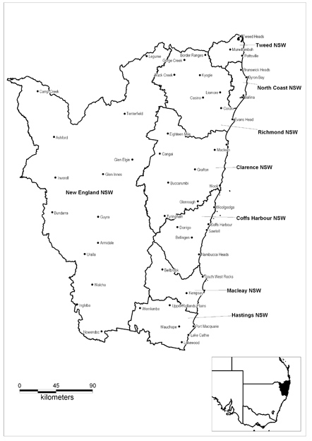
LABOUR MARKET REGION—NORTHERN NEW SOUTH WALES
Employment Service Area | Statistical Local Area
Clarence NSW | Clarence Valley—Coast, Clarence Valley—Grafton, Clarence Valley Bal
Coffs Harbour NSW | Bellingen, Coffs Harbour—Part A, Coffs Harbour—Part B, Nambucca
Hastings NSW | Hastings—Part A, Hastings—Part B
Macleay NSW | Kempsey
New England NSW | Armidale Dumaresq—City, Armidale Dumaresq Bal, Glen Innes Severn, Guyra, Inverell—Part A, Inverell—Part B, Tenterfield, Uralla, Walcha
North Coast NSW | Ballina, Byron
Richmond NSW | Kyogle, Lismore—Part A, Lismore—Part B, Richmond Valley—Casino, Richmond Valley Bal
Tweed NSW | Tweed—Part B, Tweed—Tweed Coast, Tweed—Tweed Heads

LABOUR MARKET REGION—WESTERN NEW SOUTH WALES
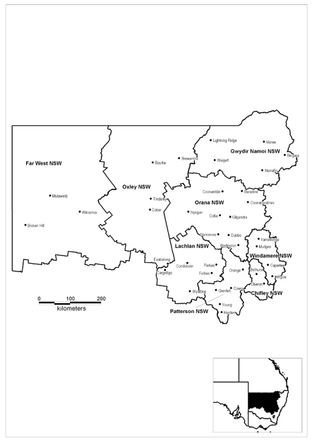
LABOUR MARKET REGION—WESTERN NEW SOUTH WALES
Employment Service Area | Statistical Local Area
Chifley NSW | Bathurst Regional—Part A, Bathurst Regional—Part B, Oberon
Far West NSW | Broken Hill, Central Darling, Unincorp. Far West
Gwydir Namoi NSW | Gwydir, Moree Plains, Narrabri, Walgett
Lachlan NSW | Bland, Forbes, Lachlan, Parkes
Orana NSW | Bogan, Coonamble, Dubbo—Part A, Dubbo—Part B, Gilgandra, Narromine, Warren, Warrumbungle Shire, Wellington
Oxley NSW | Bourke, Brewarrina, Cobar
Patterson NSW | Blayney, Boorowa, Cabonne, Cowra, Harden, Orange, Weddin, Young
Windamere NSW | Lithgow, Mid-Western Regional—Part A, Mid-Western Regional—Part B

LABOUR MARKET REGION—SOUTHERN NEW SOUTH WALES
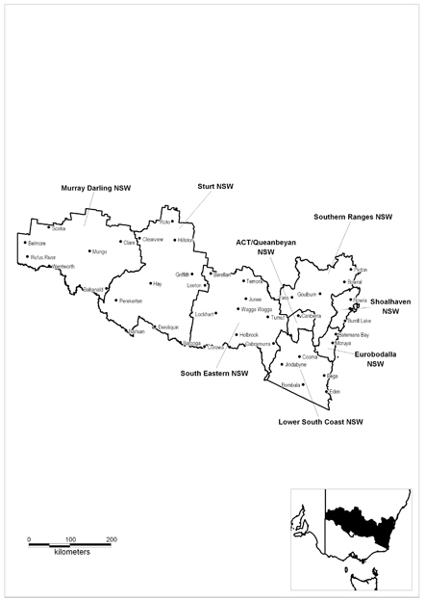
LABOUR MARKET REGION—SOUTHERN NEW SOUTH WALES
Employment Service Area | Statistical Local Area
ACT/Queanbeyan NSW | Acton, Ainslie, Amaroo, Aranda, Banks, Barton, Belconnen—SSD Bal, Belconnen Town Centre, Bonython, Braddon, Bruce, Calwell, Campbell, Chapman, Charnwood, Chifley, Chisholm, City, Conder, Cook, Curtin, Deakin, Dickson, Downer, Duffy, Dunlop, Duntroon, Evatt, Fadden, Farrer, Fisher, Florey, Flynn, Forrest, Fraser, Fyshwick, Garran, Gilmore, Giralang, Gordon, Gowrie, Greenway, Griffith, Gungahlin, Gungahlin-Hall—SSD Bal, Hackett, Hall, Harman, Harrison, Hawker, Higgins, Holder, Holt, Hughes, Hume, Isaacs, Isabella Plains, Jerrabomberra, Kaleen, Kambah, Kingston, Kowen, Latham, Lyneham, Lyons, Macarthur, Macgregor, Macquarie, Majura, Mawson, McKellar, Melba, Mitchell, Monash, Narrabundah, Ngunnawal, Nicholls, Oaks Estate, O’Connor, O’Malley, Oxley, Page, Palerang—Part A, Palmerston, Parkes, Pearce, Phillip, Pialligo, Queanbeyan, Red Hill, Reid, Remainder of ACT, Richardson, Rivett, Russell, Scullin, Spence, Stirling, Stromlo, Symonston, Theodore, Torrens, Tuggeranong—SSD Bal, Turner, Wanniassa, Waramanga, Watson, Weetangera, Weston, Weston Creek-Stromlo—SSD Bal, Yarralumla
Eurobodalla NSW | Eurobodalla
Lower South Coast NSW | Bega Valley, Bombala, Cooma-Monaro, Snowy River
Murray Darling NSW | Balranald, Wentworth
Shoalhaven NSW | Jervis Bay Territory, Kiama, Shoalhaven—Part A, Shoalhaven—Part B
South Eastern NSW | Coolamon, Cootamundra, Corowa Shire, Greater Hume Shire—Part A, Greater Hume Shire—Part B, Gundagai, Junee, Lockhart, Narrandera, Temora, Tumbarumba, Tumut Shire, Urana, Wagga Wagga—Part A, Wagga Wagga—Part B
Southern Ranges NSW | Goulburn Mulwaree—Goulburn, Goulburn Mulwaree Bal, Palerang—Part B, Upper Lachlan, Wingecarribee, Wollondilly, Yass Valley
Sturt NSW | Berrigan, Carrathool, Conargo, Deniliquin, Griffith, Hay, Jerilderie, Leeton, Murrumbidgee, Wakool

LABOUR MARKET REGION—MELBOURNE
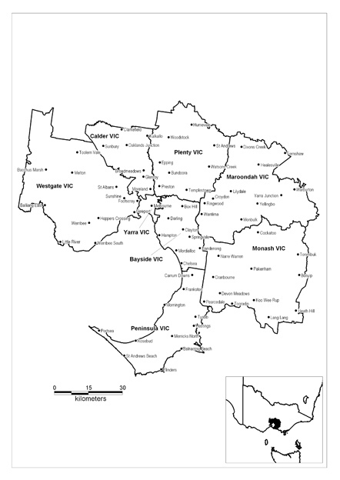

LABOUR MARKET REGION—MELBOURNE
Employment Service Area | Statistical Local Area
Bayside Vic. | Bayside—Brighton, Bayside—South, Boroondara—Camberwell North, Boroondara—Camberwell S., Boroondara—Hawthorn, Boroondara—Kew, Glen Eira—Caulfield, Glen Eira—South, Greater Dandenong—Dandenong, Greater Dandenong Bal, Kingston—North, Kingston—South, Monash—South-West, Monash—Waverley East, Monash—Waverley West, Stonnington—Malvern, Stonnington—Prahran, Whitehorse—Box Hill, Whitehorse—Nunawading East, Whitehorse—Nunawading West
Calder Vic. | Hume—Broadmeadows, Hume—Craigieburn, Hume—Sunbury, Moonee Valley—Essendon, Moonee Valley—West, Moreland—Brunswick, Moreland—Coburg, Moreland—North
Maroondah Vic. | Knox—North-East, Knox—North-West, Knox—South, Maroondah—Croydon, Maroondah—Ringwood, Yarra Ranges—Central, Yarra Ranges—Dandenongs, Yarra Ranges—Lilydale, Yarra Ranges—North, Yarra Ranges—Seville
Monash Vic. | Cardinia—North, Cardinia—Pakenham, Cardinia—South, Casey—Berwick, Casey—Cranbourne, Casey—Hallam, Casey—South
Peninsula Vic. | Frankston—East, Frankston—West, Mornington Peninsula—East, Mornington Peninsula—South, Mornington Peninsula—West
Plenty Vic. | Banyule—Heidelberg, Banyule—North, Darebin— Northcote, Darebin—Preston, Manningham—East, Manningham—West, Nillumbik—South, Nillumbik—South-West, Nillumbik Bal, Whittlesea—North, Whittlesea—South-East, Whittlesea—South-West
Westgate Vic. | Brimbank—Keilor, Brimbank—Sunshine, Hobsons Bay—Altona, Hobsons Bay—Williamstown, Maribyrnong, Melton—East, Melton Bal, Moorabool—Bacchus Marsh, Wyndham—North, Wyndham—South, Wyndham—West
Yarra Vic. | Melbourne—Inner, Melbourne—Remainder, Melbourne—Southbank-Docklands, Port Phillip—St Kilda, Port Phillip—West, Yarra—North, Yarra—Richmond

LABOUR MARKET REGION—WESTERN VICTORIA
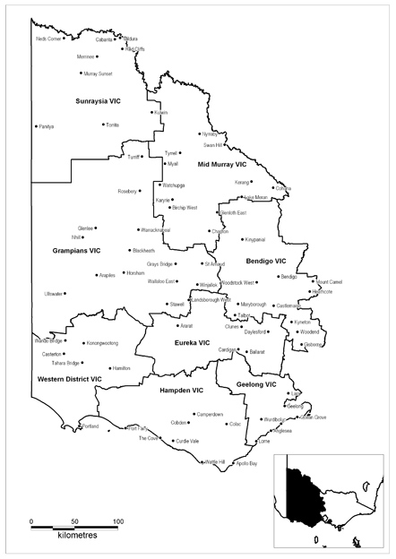
LABOUR MARKET REGION—WESTERN VICTORIA
Employment Service Area | Statistical Local Area
Bendigo Vic. | Central Goldfields—Maryborough, Central Goldfields Bal, Greater Bendigo—Central, Greater Bendigo—Eaglehawk, Greater Bendigo—Inner East, Greater Bendigo—Inner North, Greater Bendigo—Inner West, Greater Bendigo—Part B, Greater Bendigo—Strathfieldsaye, Loddon—North, Loddon—South, Macedon Ranges—Kyneton, Macedon Ranges—Romsey, Macedon Ranges Bal, Mount Alexander—Castlemaine, Mount Alexander Bal
Eureka Vic. | Ararat, Ballarat—Central, Ballarat—Inner North, Ballarat—North, Ballarat—South, Hepburn—East, Hepburn—West, Moorabool—Ballan, Moorabool—West, Pyrenees—North, Pyrenees—South
Geelong Vic. | Bellarine—Inner, Corio—Inner, Geelong, Geelong West, Golden Plains—North-West, Golden Plains—South-East, Greater Geelong—Part B, Greater Geelong—Part C, Newtown, Queenscliffe, South Barwon—Inner, Surf Coast—East, Surf Coast—West
Grampians Vic. | Hindmarsh, Horsham—Central, Horsham Bal, North Grampians—St Arnaud, North Grampians—Stawell, West Wimmera, Yarriambiack—North, Yarriambiack—South
Hampden Vic. | Colac-Otway—Colac, Colac-Otway—North, Colac-Otway—South, Corangamite—North, Corangamite—South, Lady Julia Percy Island, Moyne—North-East, Moyne—North-West, Moyne—South, Warrnambool
Mid Murray Vic. | Buloke—North, Buloke—South, Gannawarra, Swan Hill—Central, Swan Hill—Robinvale, Swan Hill—Bal
Sunraysia Vic. | Mildura—Part A, Mildura—Part B
Western District Vic. | Glenelg—Heywood, Glenelg—North, Glenelg—Portland, South Grampians—Hamilton, South Grampians—Wannon, South Grampians Bal

LABOUR MARKET REGION—EASTERN VICTORIA
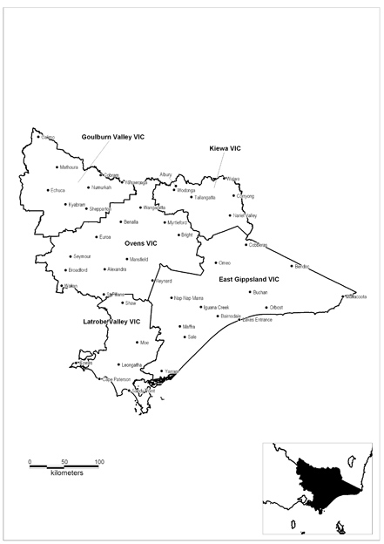

LABOUR MARKET REGION—EASTERN VICTORIA
Employment Service Area | Statistical Local Area
East Gippsland Vic. | E. Gippsland—Bairnsdale, East Gippsland—Orbost, East Gippsland—South-West, East Gippsland Bal, Wellington—Alberton, Wellington—Avon, Wellington—Maffra, Wellington—Rosedale, Wellington—Sale
Goulburn Valley Vic. | Campaspe—Echuca, Campaspe—Kyabram, Campaspe—Rochester, Campaspe—South, Greater Shepparton—Part A, Greater Shepparton—Part B East, Greater Shepparton—Part B West, Moira—East, Moira—West, Murray
Kiewa Vic. | Albury, Indigo—Part A, Towong—Part A, Towong—Part B, Wodonga
Latrobe Valley Vic. | Bass Coast—Phillip Island, Bass Coast Bal, Bass Strait Islands, Baw Baw—Part A, Baw Baw—Part B East, Baw Baw—Part B West, French Island, Latrobe—Moe, Latrobe—Morwell, Latrobe– Traralgon, Latrobe Bal, Mount Baw Baw Alpine Resort, South Gippsland—Central, South Gippsland—East, South Gippsland—West, Yarra Ranges—Part B
Ovens Vic. | Alpine—East, Alpine—West, Benalla—Benalla, Benalla Bal, Falls Creek Alpine Resort, Indigo—Part B, Lake Mountain Alpine Resort, Mansfield, Mitchell—North, Mitchell—South, Mount Buller Alpine Resort, Mount Hotham Alpine Resort, Mount Stirling Alpine Resort, Murrindindi—East, Murrindindi—West, Strathbogie, Wangaratta—Central, Wangaratta—North, Wangaratta—South

LABOUR MARKET REGION—BRISBANE
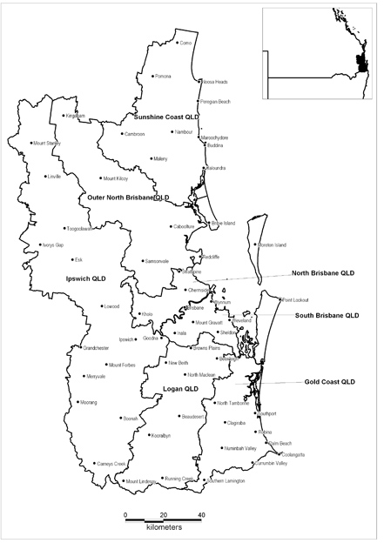

LABOUR MARKET REGION—BRISBANE
Employment Service Area | Statistical Local Area
Gold Coast Qld | Ashmore-Benowa, Beaudesert—Pt B, Biggera Waters-Labrador, Bilinga-Tugun, Broadbeach Waters, Broadbeach-Mermaid Beach, Bundall, Burleigh Heads, Burleigh Waters, Carrara-Merrimac, Coolangatta, Coombabah, Currumbin, Currumbin Valley-Tallebudgera, Currumbin Waters, Elanora, Guanaba-Springbrook, Helensvale, Hope Island, Jacobs Well-Alberton, Kingsholme-Upper Coomera, Main Beach-South Stradbroke, Mermaid Waters-Clear Island Waters, Miami, Molendinar, Mudgeeraba-Reedy Creek, Nerang, Oxenford-Maudsland, Pacific Pines-Gaven, Palm Beach, Paradise Point-Runaway Bay, Parkwood-Arundel, Pimpama-Coomera, Robina, Southport, Surfers Paradise, Varsity Lakes, Worongary-Tallai
Ipswich Qld | Boonah, Esk, Ipswich—Central, Ipswich—East, Ipswich—North, Ipswich—South-West, Ipswich—West
Logan Qld | Beaudesert—Part A, Beaudesert—Part C, Beenleigh, Bethania-Waterford, Browns Plains, Carbrook-Cornubia, Daisy Hill-Priestdale, Eagleby, Edens Landing-Holmview, Greenbank-Boronia Heights, Kingston, Logan Bal, Loganholme, Loganlea, Marsden, Mt Warren Park, Ormeau-Yatala, Rochedale South, Shailer Park, Slacks Creek, Springwood, Tanah Merah, Underwood, Waterford West, Wolffdene-Bahrs Scrub, Woodridge
North Brisbane Qld | Albany Creek, Albion, Alderley, Anstead, Ascot, Ashgrove, Aspley, Bald Hills, Banyo, Bardon, Bellbowrie, Boondall, Bowen Hills, Bracken Ridge, Bray Park, Bridgeman Downs, Brighton, Brookfield (incl. Brisbane Forest Park), Carseldine, Chapel Hill, Chermside, Chermside West, City—Inner, City—Remainder, Clayfield, Deagon, Enoggera, Everton Park, Ferny Grove, Fig Tree Pocket, Fortitude Valley, Geebung, Grange, Hamilton, Hendra, Herston, Hills District, Indooroopilly, Karana Downs-Lake Manchester, Kedron, Kelvin Grove, Kenmore, Kenmore Hills, Keperra, Lutwyche, McDowall, Milton, Mitchelton, Moggill, New Farm, Newmarket, Newstead, Northgate, Nudgee, Nundah, Paddington, Pinjarra Hills, Pinkenba-Eagle Farm, Pullenvale, Red Hill, Sandgate, Spring Hill, St Lucia, Stafford, Stafford Heights, Strathpine-Brendale, Taigum-Fitzgibbon, Taringa, The Gap, Toowong, Upper Kedron, Virginia, Wavell Heights, Wilston, Windsor, Wooloowin, Zillmere
Outer North Brisbane Qld | Bribie Island, Burpengary-Narangba, Caboolture—Central, Caboolture—East, Caboolture—Hinterland, Caboolture—Midwest, Central Pine West, Clontarf, Dakabin-Kallangur-M. Downs, Deception Bay, Griffin-Mango Hill, Kilcoy, Lawnton, Margate-Woody Point, Morayfield, Petrie, Pine Rivers Bal, Redcliffe-Scarborough, Rothwell-Kippa-Ring

South Brisbane Qld | Acacia Ridge, Alexandra Hills, Algester, Annerley, Archerfield, Balmoral, Belmont-Mackenzie, Birkdale, Bulimba, Burbank, Calamvale, Camp Hill, Cannon Hill, Capalaba, Carina, Carina Heights, Carindale, Chandler-Capalaba West, Chelmer, Cleveland, Coopers Plains, Coorparoo, Corinda, Darra-Sumner, Doolandella-Forest Lake, Durack, Dutton Park, East Brisbane, Eight Mile Plains, Ellen Grove, Fairfield, Graceville, Greenslopes, Gumdale-Ransome, Hawthorne, Hemmant-Lytton, Highgate Hill, Holland Park, Holland Park West, Inala, Jamboree Heights, Jindalee, Kangaroo Point, Kuraby, Lota, Macgregor, Manly, Manly West, Mansfield, Middle Park, Moorooka, Moreton Island, Morningside, Mount Gravatt, Mount Gravatt East, Mount Ommaney, Murarrie, Nathan, Norman Park, Ormiston, Oxley, Pallara-Heathwood-Larapinta, Parkinson-Drewvale, Redland Bal, Redland Bay, Richlands, Riverhills, Robertson, Rochedale, Rocklea, Runcorn, Salisbury, Seventeen Mile Rocks, Sheldon-Mt Cotton, Sherwood, South Brisbane, Stretton-Karawatha, Sunnybank, Sunnybank Hills, Tarragindi, Thorneside, Thornlands, Tingalpa, Upper Mount Gravatt, Victoria Point, Wacol, Wakerley, Wellington Point, West End, Westlake, Willawong, Wishart, Woolloongabba, Wynnum, Wynnum West, Yeerongpilly, Yeronga
Sunshine Coast Qld | Caloundra—Caloundra North, Caloundra—Caloundra South, Caloundra—Hinterland, Caloundra—Kawana, Caloundra—Rail Corridor, Maroochy—Buderim, Maroochy—Coastal North, Maroochy—Maroochydore, Maroochy—Mooloolaba, Maroochy—Nambour, Maroochy—Paynter-Petrie Creek, Maroochy Bal, Noosa—Noosa-Noosaville, Noosa—Sunshine-Peregian, Noosa—Tewantin, Noosa Bal
LABOUR MARKET REGION—CENTRAL AND NORTH QUEENSLAND
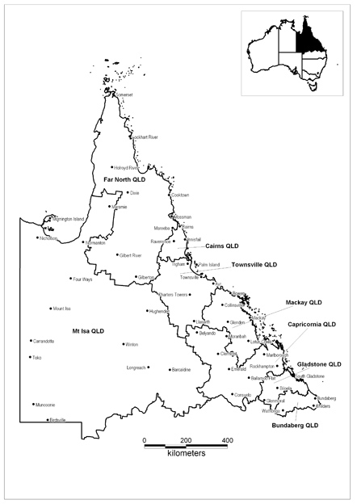

LABOUR MARKET REGION—CENTRAL AND NORTH QUEENSLAND
Employment Service Area | Statistical Local Area
Bundaberg Qld | Bundaberg, Burnett—Part A, Burnett—Part B, Eidsvold, Isis, Kolan, Monto, Perry
Cairns Qld | Atherton, Cairns—Barron, Cairns—Central Suburbs, Cairns—City, Cairns—Mt Whitfield, Cairns—Northern Suburbs, Cairns—Part B, Cairns—Trinity, Cairns—Western Suburbs, Cardwell, Douglas (Collection Districts 3010805, 3010806, 3010810, 3010812, 3010813, 3010901, 3010902, 3010903, 3010904, 3010905, 3010906, 3010907, 3010908, 3010909, 3010910, 3010911, 3010912, 3010913, 3010914, 3010915, 3010916, 3010917, 3010918, 3010919, 3010920, 3010921, 3010922, 3010923, 3010924, 3010925, 3010926 only), Eacham, Herberton, Johnstone, Mareeba (Collection Districts 3030309, 3030323, 3030401, 3030402, 3030403, 3030404, 3030405, 3030406, 3030407, 3030408, 3030409, 3030410, 3030411, 30300412 only), Yarrabah
Capricornia Qld | Bauhinia, Belyando, Duaringa, Emerald, Fitzroy—Part A, Fitzroy—Part B, Livingstone—Part A, Livingstone—Part B, Mount Morgan, Peak Downs, Rockhampton, Woorabinda
Far North Qld | Aurukun, Badu, Bamaga, Boigu, Cook, Croydon, Dauan, Douglas (Collection Districts 3010801, 3010802, 3010803, 3010804, 3010807, 3010808, 3010814 Only), Erub, Etheridge, Hammond, Hope Vale, Iama, Injinoo, Kowanyama, Kubin, Lockhart River, Mabuiag, Mapoon, Mareeba (Collection Districts 3030101, 3030102, 3030103, 3030104, 3030105, 3030106, 3030201, 3030202, 3030203, 3030204, 3030205, 3030206, 3030207, 3030208, 3030209, 3030210, 3030211, 3030301, 3030303, 3030304, 3030305, 3030306, 3030307,3030308, 3030310, 3030311, 3030312, 3030313, 3030314, 3030315, 3030316, 3030317, 3030318, 3030319, 3030320, 3030321, 3030322, 3030324 only), Mer, Napranum, New Mapoon, Pormpuraaw, Poruma, Saibai, Seisia, St Pauls, Torres, Ugar, Umagico, Warraber, Weipa, Wujal Wujal, Yorke
Gladstone Qld | Banana, Calliope—Part A, Calliope—Part B, Gladstone, Miriam Vale
Mackay Qld | Bowen, Broadsound, Mackay—Part A, Mackay—Part B, Mirani, Nebo, Sarina, Whitsunday
Mt Isa Qld | Aramac, Barcaldine, Barcoo, Blackall, Boulia, Burke, Carpentaria, Cloncurry, Diamantina, Doomadgee, Flinders, Ilfracombe, Isisford, Jericho, Longreach, McKinlay, Mornington, Mount Isa, Richmond, Tambo, Unincorp. Islands, Winton

Townsville Qld | Aitkenvale, Burdekin, Charters Towers, City, Cranbrook, Currajong, Dalrymple, Douglas, Garbutt, Gulliver, Heatley, Hermit Park, Hinchinbrook, Hyde Park-Mysterton, Kelso, Kirwan, Magnetic Island, Mt Louisa-Mt St John-Bohle, Mundingburra, Murray, North Ward-Castle Hill, Oonoonba-Idalia-Cluden, Pallarenda-Shelley Beach, Palm Island, Pimlico, Railway Estate, Rosslea, Rowes Bay-Belgian Gardens, South Townsville, Stuart-Roseneath, Thuringowa—Part A Bal, Thuringowa—Part B, Townsville—Part B, Vincent, West End, Wulguru
LABOUR MARKET REGION—SOUTHERN QUEENSLAND
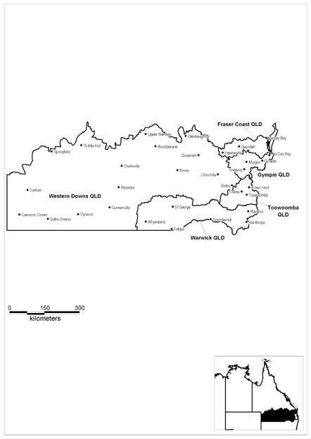

LABOUR MARKET REGION—SOUTHERN QUEENSLAND
Employment Service Area | Statistical Local Area
Fraser Coast Qld | Biggenden, Gayndah, Hervey Bay—Part A, Hervey Bay—Part B, Maryborough , Mundubbera, Tiaro, Woocoo
Gympie Qld | Cherbourg, Cooloola—Gympie only, Cooloola (excl. Gympie), Kilkivan, Kingaroy, Murgon, Nanango, Wondai
Toowoomba Qld | Cambooya—Part A, Cambooya—Part B, Clifton, Crows Nest—Part A, Crows Nest—Part B, Gatton, Jondaryan—Part A, Jondaryan—Part B, Laidley, Millmerran, Pittsworth, Rosalie—Part A, Rosalie—Part B, Toowoomba—Central, Toowoomba—North-East, Toowoomba—North-West, Toowoomba—South-East, Toowoomba—West
Warwick Qld | Balonne, Goondiwindi, Inglewood, Stanthorpe, Waggamba, Warwick—Central, Warwick—East, Warwick—North, Warwick—West
Western Downs Qld | Bendemere, Booringa, Bulloo, Bungil, Chinchilla, Dalby, Murilla, Murweh, Paroo, Quilpie, Roma, Tara, Taroom, Wambo, Warroo

LABOUR MARKET REGION—ADELAIDE
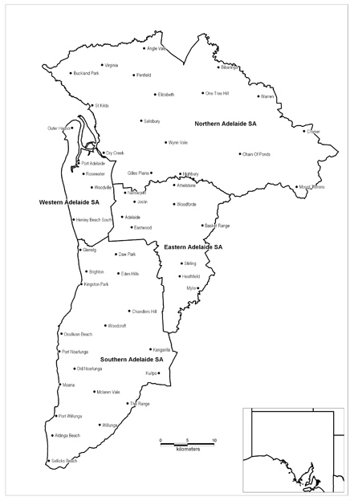

LABOUR MARKET REGION—ADELAIDE
Employment Service Area | Statistical Local Area
Eastern Adelaide SA | Adelaide, Adelaide Hills—Central, Adelaide Hills—Ranges, Burnside—North-East, Burnside—South-West, Campbelltown—East, Campbelltown—West, Norwood, Payneham & St Peters—East, Norwood, Payneham & St Peters, Prospect, Unley—East, Unley—West, Walkerville
Northern Adelaide SA | Adelaide Hills—North, Playford—East Central, Playford—Elizabeth, Playford—Hills, Playford—West, Playford—West Central, Port Adel. Enfield—East, Port Adel. Enfield—Inner, Salisbury—Central, Salisbury—Inner North, Salisbury—North-East, Salisbury—South-East, Salisbury Bal, Tea Tree Gully—Central, Tea Tree Gully—Hills, Tea Tree Gully—North, Tea Tree Gully—South
Southern Adelaide SA | Holdfast Bay—North, Holdfast Bay—South, Marion—Central, Marion—North, Marion—South, Mitcham—Hills, Mitcham—North-East, Mitcham—West, Onkaparinga—Hackham, Onkaparinga—Hills, Onkaparinga—Morphett, Onkaparinga—North Coast, Onkaparinga—Reservoir, Onkaparinga—South Coast, Onkaparinga—Woodcroft
Western Adelaide SA | Charles Sturt—Coastal, Charles Sturt—Inner East, Charles Sturt—Inner West, Charles Sturt—North-East, Port Adelaide Enfield—Coast, Port Adelaide Enfield—Park, Port Adelaide Enfield—Port, Unincorp. Western, West Torrens—East, West Torrens—West

LABOUR MARKET REGION—SOUTH AUSTRALIA COUNTRY
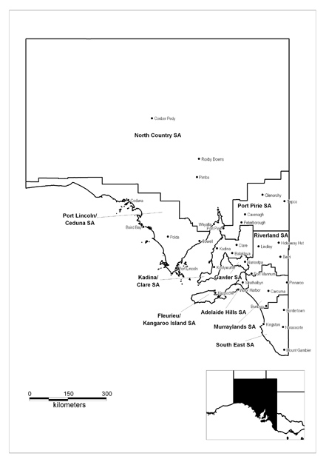

LABOUR MARKET REGION—SOUTH AUSTRALIA COUNTRY
Employment Service Area | Statistical Local Area
Adelaide Hills SA | Adelaide Hills Bal, Alexandrina—Strathalbyn, Mount Barker—Central, Mount Barker Bal
Fleurieu/Kangaroo Island SA | Alexandrina—Coastal, Kangaroo Island, Victor Harbor, Yankalilla
Gawler SA | Barossa—Angaston, Barossa—Barossa, Barossa—Tanunda, Gawler, Light, Mallala
Kadina/Clare SA | Barunga West, Clare and Gilbert Valleys, Copper Coast, Goyder, Unincorp. Yorke, Wakefield, Yorke Peninsula—North, Yorke Peninsula—South
Murraylands SA | Karoonda East Murray, Murray Bridge, Southern Mallee, The Coorong, Unincorp. Murray Mallee
North Country SA | Anangu Pitjantjatjara, Coober Pedy, Flinders Ranges, Maralinga Tjarutja, Mount Remarkable, Port Augusta, Roxby Downs, Unincorp. Far North, Unincorp. Flinders Ranges, Unincorp. Whyalla, Whyalla
Port Lincoln/Ceduna SA | Ceduna, Cleve, Elliston, Franklin Harbour, Kimba, Le Hunte, Lower Eyre Peninsula, Port Lincoln, Streaky Bay, Tumby Bay, Unincorp. Lincoln, Unincorp. West Coast
Port Pirie SA | Northern Areas, Orroroo/Carrieton, Peterborough, Port Pirie C Dists—City, Port Pirie C Dists Bal, Unincorp. Pirie
Riverland SA | Berri and Barmera—Barmera, Berri and Barmera—Berri, Loxton Waikerie—East, Loxton Waikerie—West, Mid Murray, Renmark Paringa—Paringa, Renmark Paringa—Renmark, Unincorp. Riverland
South East SA | Grant, Kingston, Mount Gambier, Naracoorte and Lucindale, Robe, Tatiara, Wattle Range—East, Wattle Range—West

LABOUR MARKET REGION—PERTH
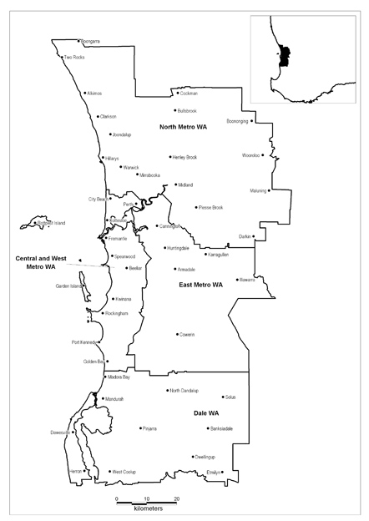

LABOUR MARKET REGION—PERTH
Employment Service Area | Statistical Local Area
Central and West Metro WA | Cambridge, Claremont, Cockburn, Cottesloe, East Fremantle, Fremantle—Inner, Fremantle—Remainder, Kwinana, Melville, Mosman Park, Nedlands, Peppermint Grove, Perth—Inner, Perth—Remainder, Rockingham, Subiaco, Vincent
Dale WA | Mandurah, Murray
East Metro WA | Armadale, Belmont, Canning, Gosnells, Serpentine-Jarrahdale, South Perth, Victoria Park
North Metro WA | Bassendean, Bayswater, Joondalup—North, Joondalup—South, Kalamunda, Mundaring, Stirling—Central, Stirling—Coastal, Stirling—South-Eastern, Swan, Wanneroo—North-East, Wanneroo—North-West, Wanneroo—South

LABOUR MARKET REGION—GREATER WESTERN AUSTRALIA
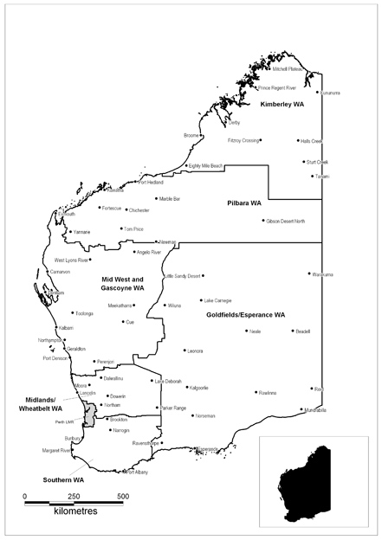

LABOUR MARKET REGION—GREATER WESTERN AUSTRALIA
Employment Service Area | Statistical Local Area
Goldfields/  Esperance WA | Coolgardie, Dundas, Esperance, Kalgoorlie/Boulder—Part A, Kalgoorlie/Boulder—Part B, Laverton, Leonora, Menzies, Ngaanyatjarraku, Ravensthorpe, Wiluna
Kimberley WA | Broome, Derby-West Kimberley, Halls Creek, Wyndham-East Kimberley
Mid West and Gascoyne WA | Carnamah, Carnarvon, Chapman Valley, Coorow, Cue, Exmouth, Geraldton, Greenough—Part A, Greenough—Part B, Irwin, Meekatharra, Mingenew, Morawa, Mount Magnet, Mullewa, Murchison, Northampton, Perenjori, Sandstone, Shark Bay, Territory of Christmas Island, Territory of Cocos (Keeling) Islands, Three Springs, Upper Gascoyne, Yalgoo
Midlands/Wheatbelt WA | Beverley, Bruce Rock, Chittering, Cunderdin, Dalwallinu, Dandaragan, Dowerin, Gingin, Goomalling, Kellerberrin, Koorda, Merredin, Moora, Mount Marshall, Mukinbudin, Narembeen, Northam (S), Northam (T), Nungarin, Quairading, Tammin, Toodyay, Trayning, Victoria Plains, Westonia, Wongan-Ballidu, Wyalkatchem, Yilgarn, York
Pilbara WA | Ashburton, East Pilbara, Port Hedland, Roebourne
Southern WA | Albany—Central, Albany Bal, Augusta-Margaret River, Boddington, Boyup Brook, Bridgetown-Greenbushes, Brookton, Broomehill, Bunbury, Busselton, Capel—Part A, Capel—Part B, Collie, Corrigin, Cranbrook, Cuballing, Dardanup—Part A, Dardanup—Part B, Denmark, Donnybrook-Balingup, Dumbleyung, Gnowangerup, Harvey—Part A, Harvey—Part B, Jerramungup, Katanning, Kent, Kojonup, Kondinin, Kulin, Lake Grace, Manjimup, Nannup, Narrogin (S), Narrogin (T), Pingelly, Plantagenet, Tambellup, Wagin, Wandering, Waroona, West Arthur, Wickepin, Williams, Woodanilling

LABOUR MARKET REGION—TASMANIA
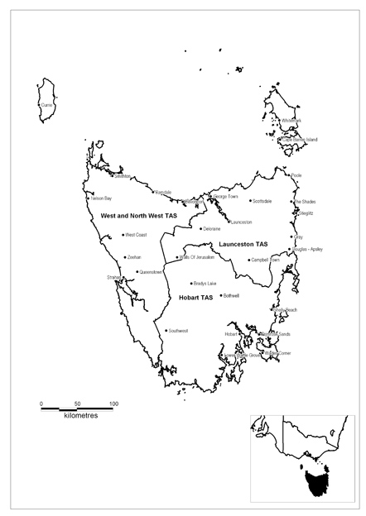

LABOUR MARKET REGION—TASMANIA
Employment Service Area | Statistical Local Area
Hobart Tas. | Brighton, Central Highlands, Clarence, Derwent Valley—Part A, Derwent Valley—Part B, Glamorgan/Spring Bay, Glenorchy, Hobart—Inner, Hobart—Remainder, Huon Valley, Kingborough—Part A, Kingborough—Part B, Sorell—Part A, Sorell—Part B, Southern Midlands, Tasman
Launceston Tas. | Break O’Day, Dorset, Flinders, George Town Part A, George Town Part B, Launceston—Inner, Launceston—Part B, Launceston—Part C, Meander Valley—Part A, Meander Valley—Part B, Northern Midlands—Part A, Northern Midlands—Part B, West Tamar—Part A, West Tamar—Part B
West and North West Tas. | Burnie—Part A, Burnie—Part B, Central Coast—Part A, Central Coast—Part B, Circular Head, Devonport, Kentish, King Island, Latrobe—Part A, Latrobe—Part B, Waratah/Wynyard—Part A, Waratah/Wynyard—Part B, West Coast

LABOUR MARKET REGION—NORTHERN TERRITORY
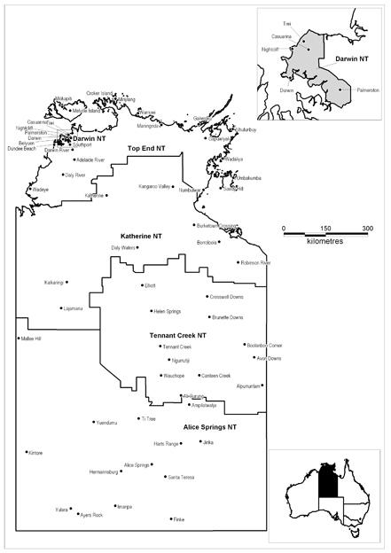

LABOUR MARKET REGION—NORTHERN TERRITORY
Employment Service Area | Statistical Local Area
Alice Springs NT | Alice Springs—Charles, Alice Springs- Heavitree, Alice Springs—Larapinta, Alice Springs—Ross, Alice Springs—Stuart, Anmatjere, Arltarlpilta, Hanson, Ltyentye Purte, Petermann-Simpson, Sandover, Tanami, Tapatjatjaka, Wallace Rockhole, Watiyawanu, Yuendumu
Darwin NT | Alawa, Anula, Bakewell, Bayview-Woolner, Brinkin, City—Inner, City—Remainder, Coconut Grove, Driver, Durack, East Arm, Fannie Bay, Gray, Gunn-Palmerston City, Jingili, Karama, Larrakeyah, Leanyer, Lee Point-Leanyer Swamp, Ludmilla, Malak, Marrara, Millner, Moil, Moulden, Nakara, Narrows, Nightcliff, Palmerston Bal, Parap, Rapid Creek, Stuart Park, The Gardens, Tiwi, Wagaman, Wanguri, Winnellie, Woodroffe, Wulagi
Katherine NT | Binjari, Borroloola, Daguragu, Elsey, Gulf, Jilkminggan, Katherine, Lajamanu, Mataranka, Nyirranggulung Mardrulk Ngadberre, Timber Creek, Victoria, Walangeri Ngumpinku, Yugul Mangi
Tennant Creek NT | Alpurrurulam, Elliott District, Tableland, Tennant Creek—Bal, Tennant Creek
Top End NT | Angurugu, Belyuen, Coomalie, Cox Peninsula, Cox-Finniss, Daly, East Arnhem—Bal, Groote Eylandt, Jabiru, Kunbarllanjnja, Litchfield—Part A, Litchfield—Part B, Marngarr, Nauiyu Nambiyu, Nhulunbuy, Numbulwar Numburindi, Pine Creek, South Alligator, Thamarrurr, Tiwi Islands, West Arnhem

Remote Areas
There were 15 ESAs across Australia that were designated as Remote ESAs. Within these Remote ESAs, a limited number of locations (such as regional centres with more active labour markets) have been excised as non-remote. There is also one remote location (Palm Island) within a non-remote ESA (Townsville). The Remote ESAs and the excised locations are listed in Table B.1.
Table B.1: Remote ESAs and Excised Non-remote Areas
State | Remote ESA | Excised Non-remote Areas
Qld | Far North Qld | N/A
 | Mt Isa | Mt Isa
 | Western Downs | All eastern segments of ESA, including Roma
NSW | Far West NSW | Broken Hill
 | Oxley | N/A
NT | Alice Springs | Alice Springs
 | Katherine | N/A
 | Tennant Creek | N/A
 | Top End | N/A
SA | North Country | Port Augusta, Whyalla
 | Port Lincoln/Ceduna | Port Lincoln
WA | Goldfields/Esperance | Kalgoorlie, Esperance
 | Kimberley | Broome
 | Mid West and Gascoyne | Geraldton
 | Pilbara | N/A

Non-Remote ESA with Remote Areas identified
State | Non-Remote ESA | Remote Areas
Qld | Townsville | Palm Island

When reading the tables please note:
The first column lists the excised area.
The second column lists the boundary descriptor for the excised area. Each area is based on Australian Bureau of Statistics definitions. More information on Australian Bureau of Statistics definitions can be found at abs.gov.au
REMOTE ESA—QLD
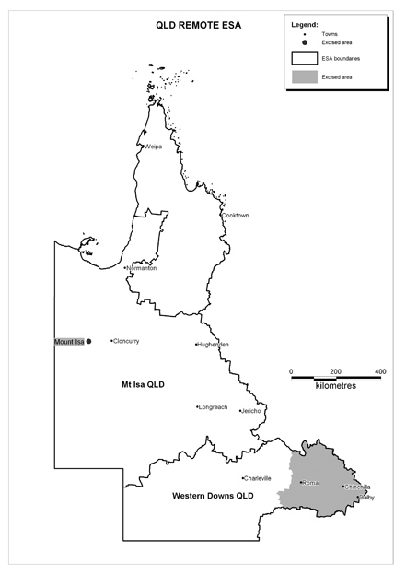
REMOTE AREA—NSW
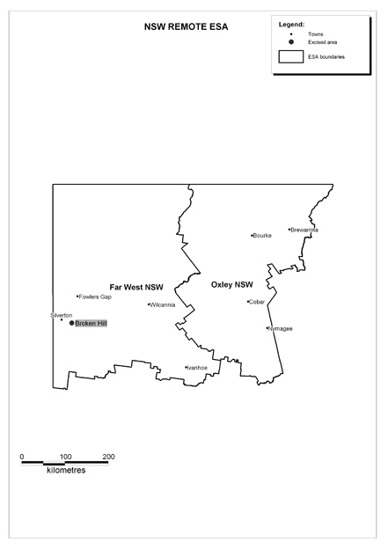

REMOTE AREA—NT
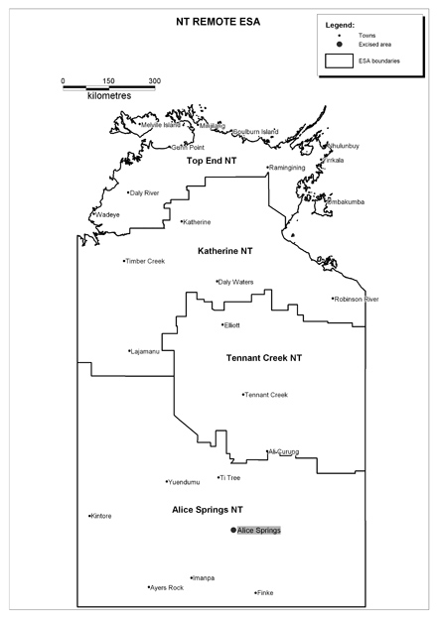
REMOTE AREA—SA
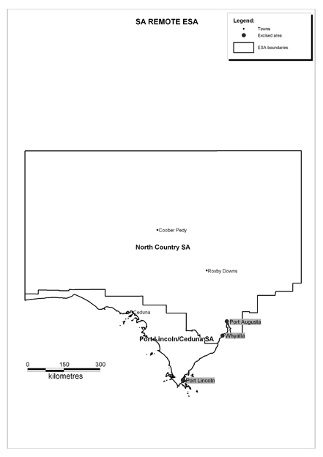

REMOTE AREA—WA
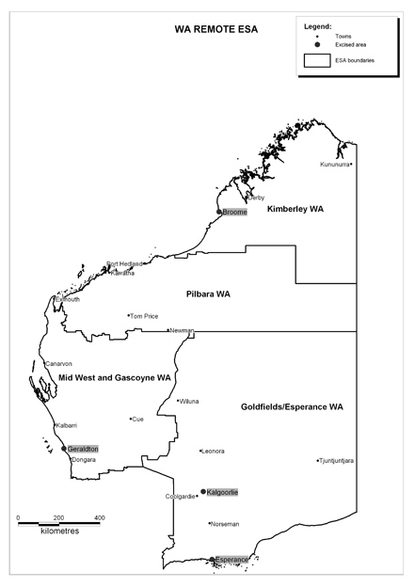
REMOTE AREA—PALM ISLAND
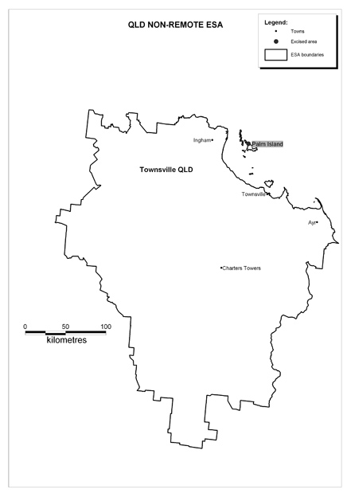
EXCISED AREA—western downs
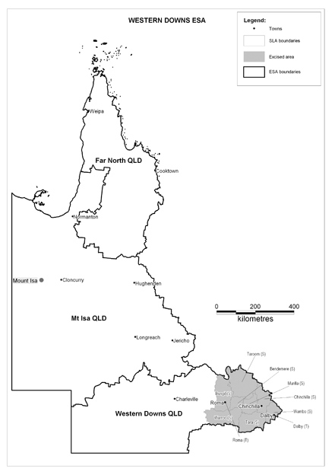
Excised Area | Boundary
All eastern segment of ESA, including Roma | The Statistical Local Areas of Warroo, Roma, Bungil, Taroom, Bendemere, Murilla, Tara, Chinchilla, Wambo, Dalby

EXCISED AREA—Broken hill
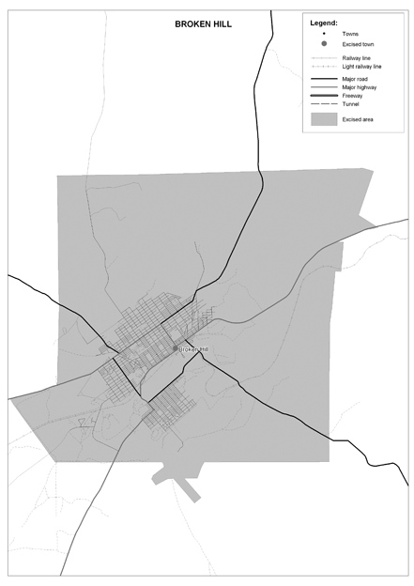
Excised Area | Boundary
Broken Hill | The Statistical Local Area of Broken Hill

EXCISED AREA—Alice springs
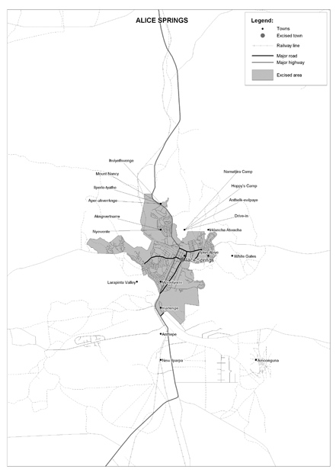
Excised Area | Boundary
Alice Springs | The Urban Centre Locality of Alice Springs

EXCISED AREA—PORT AUGUSTA
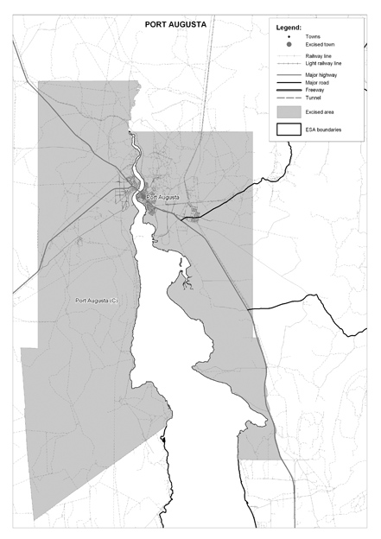
Excised Area | Boundary
Port Augusta | The Statistical Local Area of Port Augusta

EXCISED AREA—WHYALLA
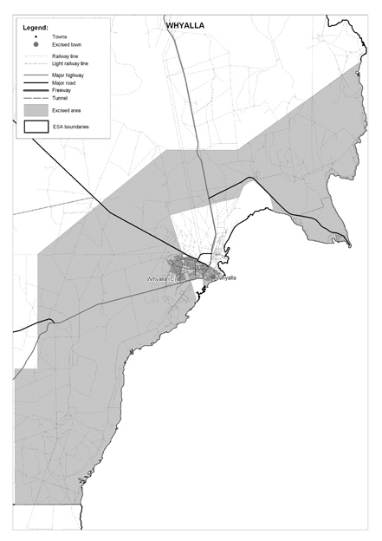
Excised Area | Boundary
Whyalla | The Statistical Local Area of Whyalla

EXCISED AREA—PORT LINCOLN
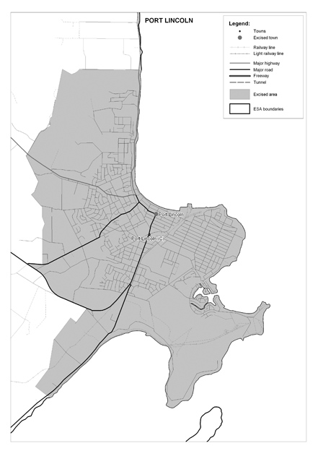
Excised Area | Boundary
Port Lincoln | The Urban Centre Locality of Port Lincoln

EXCISED AREA—KALGOORLIE
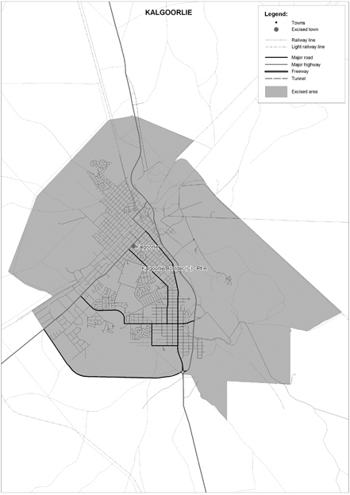
Excised Area | Boundary
Kalgoorlie | The Statistical Local Area of Kalgoorlie/ Boulder – Part A.

EXCISED AREA—ESPERANCE
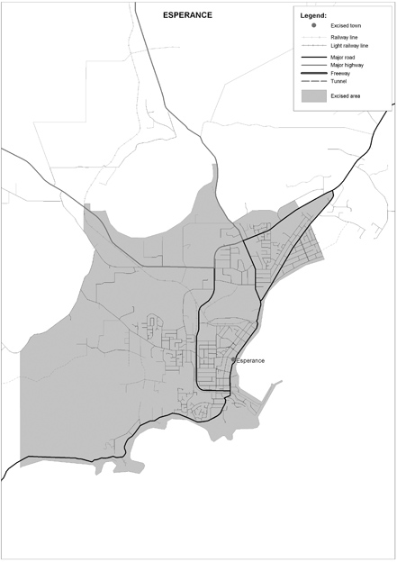
Excised Area | Boundary
Esperance | The Urban Centre Locality of Esperance

EXCISED AREA—BROOME
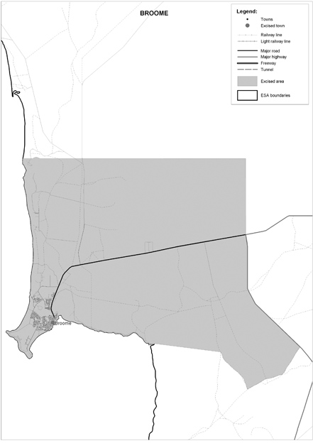
Excised Area | Boundary
Broome | The Urban Centre Locality of Broome

EXCISED AREA—GERALDTON
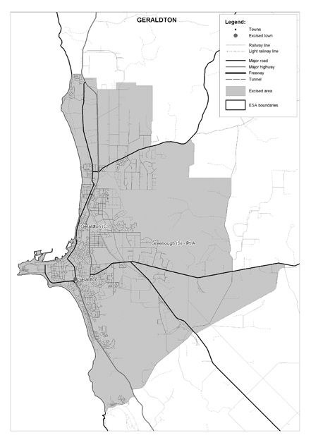
Excised Area | Boundary
Geraldton | The Statistical Local Areas of Geraldton and Greenough – Part A

