# Guide to motor vehicle searches on the PPSR

## Why are we publishing this?

People who are buying a car privately can search the PPSR to check whether there is money owing on the car. If the search shows there is debt registered on the PPSR for the car and they still buy or lease the car, the finance company listed on the PPSR might repossess the car if the seller stops making payments.

We haven’t had a chance to analyse the data from motor vehicle searches, so we’re open to surprises! Our challenge is understanding what effect these searches have, and whether we can improve service delivery.

This is a one-off dataset on searches conducted on motor vehicles on the PPSR, and the results shown. The search results are the results that users received when they searched the PPSR. The National Motor Vehicle Theft Reduction Council’s (NMVTRC) Comprehensive Auto-theft research System (CARS) have enriched our data with information on the type of vehicle, details on theft and risk of theft and estimated value of the motor vehicle.

## Summary table of the dataset

|  |  |  |
| --- | --- | --- |
| **Field** | **Description** | **Type of data** |
| YearMonth | Year and month that the motor vehicle search was conducted on the PPSR | Date displayed as YYYY-MM. Cells are blank if we do not have this information available. |
| IdentifierType | Description of type of identifier searched e.g. VIN, Chassis – this is not the actual identifier number. Most motor vehicle searches use the Vehicle Identifier Number (VIN). | Text field - contains alphabetical characters e.g. VIN. Cells are blank if we do not have this information available. |
| Make | Make of motor vehicle being searched | Text field - contains alphabetical characters. Cells are NULL or blank if we do not have this information available. |
| Model | Model of motor vehicle being searched | Text field – contains alphabetical and/or numeric characters. Cells are NULL or blank if we do not have this information available. |
| Colour | Colour of motor vehicle being searched | Text field - contains alphabetical characters. Cells are blank if we do not have this information available. |
| ComplianceDate | A compliance plate confirms that the motor vehicle complies with Australian standards. The date that the importer or manufacturer fitted it to the vehicle is the compliance date. Due to factors such as transport time, this can be different to the date of manufacture. | Date displayed as YYYY-MM. Cells are blank if we do not have this information available. |
| Encumbered | The search result of whether there is outstanding debt owing on the motor vehicle (based on the identifier provided). | Binary numerical field:  0: there is a no outstanding debt on the PPSR against the vehicle  1: there is outstanding debt on the PPSR against the vehicle |
| MarketSegment | Passenger and light commercial vehicle market segment. | Text field – contains alphabetical characters specifying: small, medium, large, SUV, sports, light commercial vehicle.  Cells are NULL or blank if we do not have this information available. |
| AusTheft | Number of thefts for that corresponding make/model/series year range2 in that calendar year that that VIN matched to. | Numeric e.g. 123  Cells are NULL or blank if we do not have this information available. |
| AusRegistration | Number of registrations based on make, model and series year. This dataset reports it at 30 June of the particular calendar year. | Numeric e.g. 123456  Cells are NULL or blank if we do not have this information available. |
| AusStarRating | Risk rating for based on make, model and series year range in terms of number of stars. | Text indicating level of risk (low to high) and number of stars assigned as a risk rating (1 to 5). E.g. Medium risk – 3.5 stars.  Cells are NULL or blank if we do not have this information available. We recommend using compliance date if you are using this field to avoid getting the multiple risk ratings for the same make and model. |
| EstimatedValue | Estimated vehicle value when the PPSR search was conducted. | Numeric in dollars. E.g. 12345.  Cells are NULL or blank if we do not have this information available. |

## Additional notes on this data

The NMVTRC’s Comprehensive Auto-theft Research System (CARS) have enriched our data with information on the type of vehicle, details on theft and risk of theft and estimated value of the motor vehicle. This can only occur for motor vehicle searches conducted using a VIN for passenger and light commercial vehicles (PLCs). By far the majority of motor vehicle searches are for PLCs. We have left information blank when we do not have it available – for example, for motorcycles, caravans, trailers, plant and equipment.

Motor vehicle searches on the PPSR in 2012 do not have additional data available due to a change in classification for theft risk ratings.

Theft risk ratings for motor vehicle searches conducted in 2017 show the theft risk rating in 2016, as that is the latest theft risk rating we have at this point in time.

## Understanding PPSR motor vehicle search results

On your search certificate, look at the information under the heading ‘PPSR Registration Details’. The results will either show no security interest or other registration (like the sample certificate below left), or one or more registrations (image at right below). Note: ‘Registration Details’ refers to the PPSR registration, not the number plate or road registration of a vehicle.

[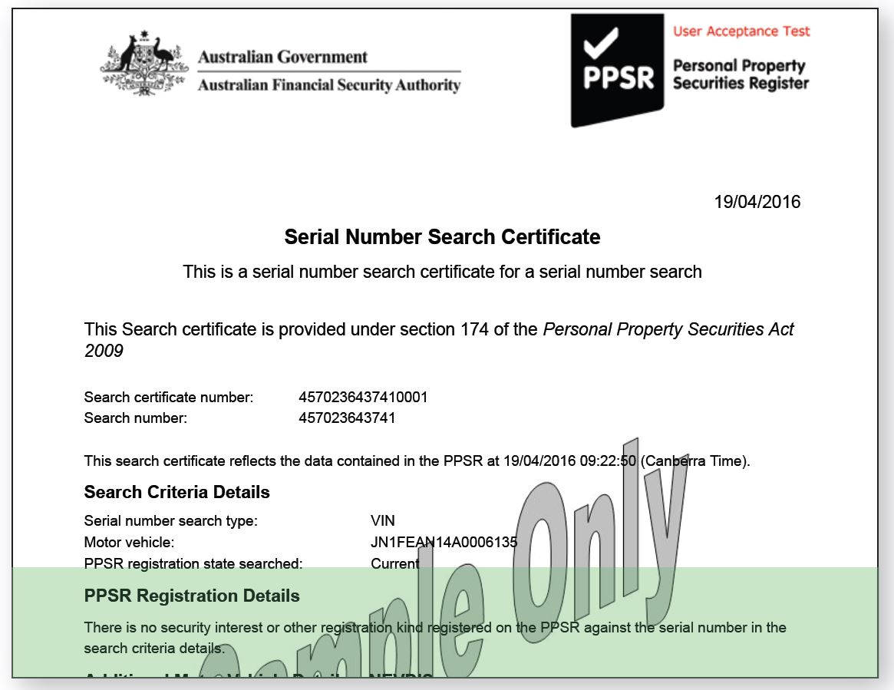](https://www.ppsr.gov.au/sites/g/files/net776/f/Sample%20Search%20Certificate%20Green.JPG)

If your certificate says, ‘There is no security interest or other registration kind registered on the PPSR against the serial number in the search criteria details’, this means there is no outstanding debt recorded on the PPSR against that vehicle’s serial number (such as the VIN).

[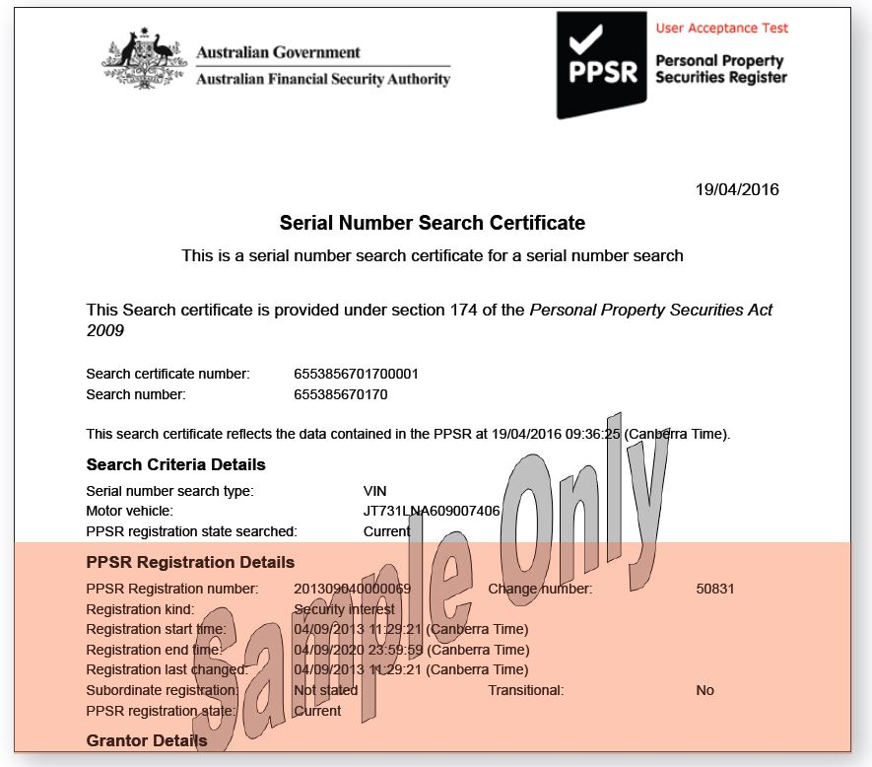](https://www.ppsr.gov.au/sites/g/files/net776/f/Sample%20Search%20Certificate%20Red.JPG)

Your search shows one or more registrations. This means there is outstanding debt on the PPSR against the vehicle’s serial number (such as the VIN).

Your PPSR certificate also provides information from the National Exchange of Vehicle and Driver Information System (NEVDIS). This information helps you to check the accuracy of the Vehicle Identification Number (VIN), serial or chassis number, or information about the vehicle from other sources.

It also gives you any data held on NEVDIS about whether the vehicle is stolen or has been written-off. NEVDIS is a national database of all registered vehicles in Australia, compiled from data provided by state and territory road agencies.  To get further information on details in the Additional Motor Vehicle section, you can speak to the seller, who can contact the state or territory road agency about enquiries, errors and corrections.