

Australian ground cover reference sites database 2014:   User guide for PostGIS

Jasmine Rickards, Jane Stewart, Rebecca McPhee & Lucy Randall

Australian Bureau of Agricultural and Resource Economics and Sciences

September 2014

# Summary

Ground cover is the amount of living and dead vegetation in contact with the soil surface. Spatially explicit monthly ground cover data are needed to improve modelling and monitoring of wind and water erosion, soil carbon and soil acidification.

The Ground cover monitoring for Australia project has delivered a remotely sensed ground cover product describing green or photosynthetic vegetation, non-green or non-photosynthetic vegetation and bare soil. The project has also delivered a national network of sensor independent ground reference sites to validate this product. The reference site data were collected by relevant state and territory agencies. The project was funded by the Department of Agriculture and coordinated by its Australian Bureau of Agricultural and Resource Economics and Sciences (ABARES) in partnership with the CSIRO and state and territory agencies.

The ground cover reference sites database contains the data collected from the national network of ground cover reference sites. The data includes site descriptions and associated field measurements of fractional ground cover. Data were collected across Australia from July 2010 to June 2014 at field sites under grazing and broadacre cropping land uses according to nationally agreed standards (Muir et al. 2011). The database is an update from the 2013 version and now contains published field observations current as at August 2014. This includes information from additional sites and corrects identified errors. The database now contains 507 observations from 486 unique sites across Australia. The data are being used to calibrate, validate and improve vegetation fractional cover products derived from remote sensing, in particular the satellite sensors MODIS and Landsat. The data are being used to improve the national MODIS-derived product of Guerschman et al. (2009, 2012, 2014).

The ground cover reference sites database has been developed using open source software—the object-relational database PostgreSQL with PostGIS to support geographic objects. This enables the database to be displayed spatially by site location within geographical information systems. The data is published through the Terrestrial Ecosystem Research Network (TERN) National Computational Infrastructure (<https://rs.nci.org.au/u39/public/html/index.shtml>), Australian Ecological Knowledge and Observation System (AEKOS) Data Portal (<http://www.aekos.org.au/home>), and Soils to Satellites website (<http://www.soils2satellites.org.au>).

Contents

Summary 1

Introduction 3

Observations in the database 4

Database design 5

Field collection protocols 6

Raw transect data 8

Photographs 8

Site description 9

Site locations 13

Cover summaries 14

Cover fractions 14

Exposed cover fractions 15

Checking the data 15

SQL functions 16

Querying the database 16

Manipulating the database 17

Appendix A. Other fractional cover reference site data 18

Fractional cover observations 21

Data collection 22

Appendix B. Translation of TERN AusPlots fractional cover reference site data 24

Acronyms 28

References 29

# Introduction

A national remotely sensed fractional cover product is necessary to monitor ground cover levels. Ground cover is a key input to wind and water erosion modelling to predict rates of soil loss, and to monitor the impact of different management practices on ground cover levels and soil erosion risk. It also has applications for managing agricultural assets. Ground cover is defined as the non-woody vegetation and litter covering the soil surface and can be monitored using remote sensing. At a national workshop in November 2009 the MODIS-derived vegetation fractional cover product of Guerschman et al. (2009) was selected for national monitoring of ground cover (Stewart et al. 2011). The workshop also identified the need for a national network of ground cover reference sites to calibrate, validate and improve the accuracy of ground cover estimates. To meet this objective, national standards were developed to collect field measurements of ground cover and to describe sites, with all states and the Northern Territory receiving training in their use (Muir et al. 2011).

The national network of ground cover reference sites commenced in July 2010 and was funded to June 2014. Information from 596 field sites (643 observations) has been delivered as part of the Ground cover monitoring for Australia project. This work was funded by the Department of Agriculture and coordinated by the Australian Bureau of Agricultural and Resource Economics and Sciences (ABARES) in partnership with the CSIRO and state agencies. Details of the project outputs to June 2013 are described in Stewart et al. (2014). The data was collected by the following state agencies:

* New South Wales Office of Environment and Heritage,
* Northern Territory Department of Land Resource Management,
* Queensland Department of Science, Information Technology, Innovation and the Arts,
* South Australian Department of Environment, Water and Natural Resources,
* Tasmanian Department of Primary Industries, Parks, Water and Environment,
* Victorian Department of Environment and Primary Industries, and the
* Western Australian Department of Agriculture and Food.

The updated reference sites database now contains 507 observations from 486 unique sites. This adds 43 observations and 26 sites to the database published in 2013.

The data were collected in the field and entered into two Microsoft Excel spreadsheets—the site description form and the transect form—and provided to ABARES with digital site photographs. These photos were included in the ground cover reference sites database.

The ground cover reference sites database conforms to the methods described in Muir et al. (2011). Choice of site locations was informed by a sampling strategy (Malthus et al. 2013) and sampling protocols (Stewart et al. 2012; Stewart et al. 2013). Sites were preferentially located in areas dominated by non-woody vegetation with tree canopy cover less than 20 per cent under grazing or broadacre cropping land uses. Areas with tree cover greater than 20 per cent (based on Montreal Process Implementation Group for Australia 2008), and non-agricultural land uses such as urban, conservation or indigenous land uses (based on ABARES 2011) were avoided where possible. The majority of sites are located in the rangelands. Data collection in 2014 targeted Interim Biogeographic Regionalisation for Australia (IBRA) regions with few sites.

In developing the database, users requested that it be created using open source software and have the ability to display site data within a geographical information system (GIS). PostGIS was chosen as it enables the object-relational database PostgreSQL to serve the site data spatially by site location, and to query the data using SQL functions. The SQL functions section of this user guide provides some examples. The user guide is an update to a previous version released in 2013 (Rickards et al. 2013).

The appendices of this user guide describe other field observations made available to ABARES as at August 2014 for the validation of remotely sensed fractional cover. This is an additional 1207 field observations from 773 unique sites. These additional observations have not been publically released, or have been collected using slightly different methods such as the TERN AusPlots (rangelands) method.

# Observations in the database

This field site database contains 507 observations from 486 unique sites across Australia. The database does not contain all 643 observations collected under the Ground cover monitoring for Australia project because some project partners requested that field observations on private land not be published due to confidentiality. The total number of observations collected by each state is shown in Table 1. The locations of the publishable sites in the database are shown in Map 1.

Table 1 Number of observations in each state

|  |  |  |  |
| --- | --- | --- | --- |
|  | **Observations** | | |
| **State** | **Total** | **Published** | **Unpublished** |
| New South Wales | 91 | 58 | 33 |
| Northern Territory | 118 | 103 | 15 |
| Queensland | 30 | 28 | 2 |
| South Australia | 109 | 97 | 12 |
| Tasmania | 25 | 25 | - |
| Victoria* | 119 | 45 | 74 |
| Western Australia | 151 | 151 | - |
| **Total** | **643** | **507** | **136** |

Note: Data from unpublished sites may be acquired for specific research projects at the discretion of the relevant state agency. *Of the 119 observations collected by the Victorian Department of Environment and Primary Industries, 48 were directly funded through the Ground cover monitoring for Australia project

Map 1 Location of sites in the database as at August 2014

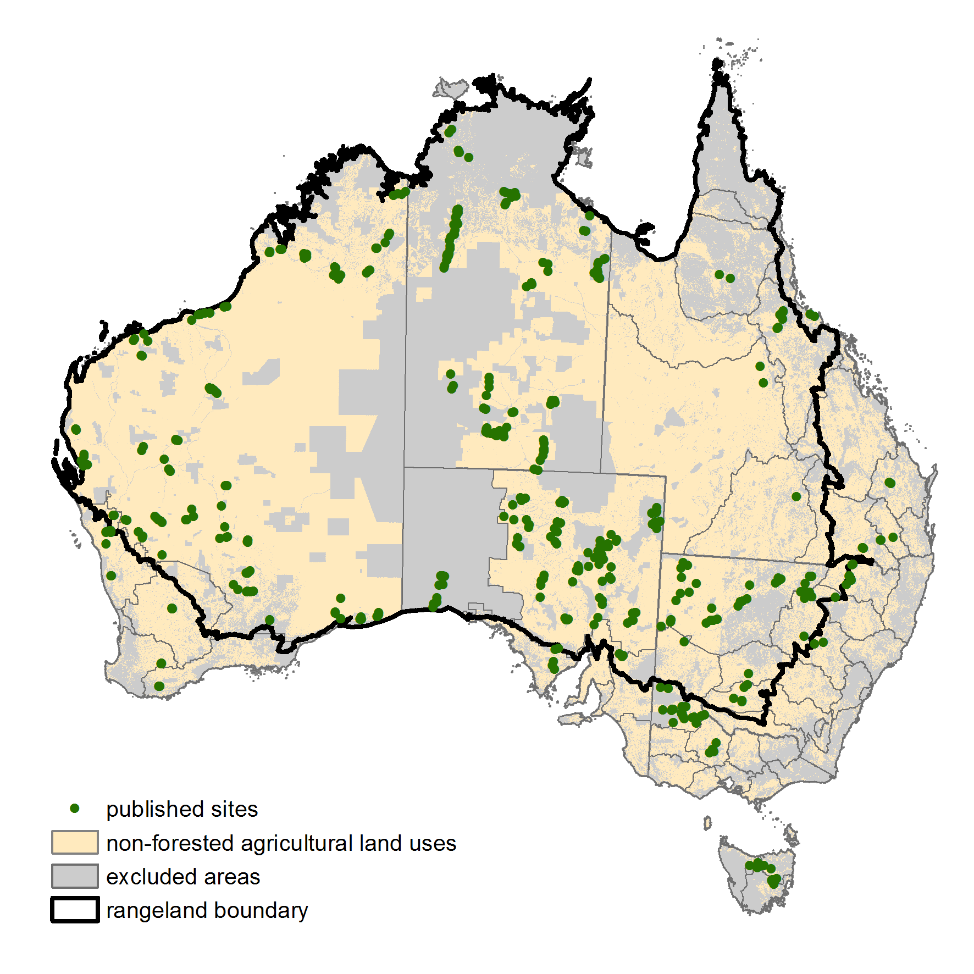

Source: ABARES 2014

# Database design

The ground cover reference sites database has been created using the open source software PostGIS (<http://postgis.refractions.net/>) and is available as a pg-dump SQL file. It can be loaded into PostGIS by running the pg-dump file. Running this file will create and populate five ‘tables’ and three ‘views’ (schema shown in Figure 1). Tables contain static data. Views calculate values from the tables and automatically update when new data is entered into the tables.

A description of each table and view are given in Table 2. The attributes contained in each table are provided in Tables 3 to 12. Each site visit is assigned a 'unique_obs' code of 'longitude_latitude_date' to join or relate all tables. Each table also contains a ‘primary key’ which is unique for each data entry at a site. For attributes with a single data entry, such as in the site description table (Table 5), the ‘primary key’ is the ‘unique_obs’ code. For attributes with multiple data entries, such as in the raw transect data table (Table 3) with 200-300 points per site, the ‘primary key’ is either a new field or a combination of existing fields.

Figure 1 Schema of PostGIS database

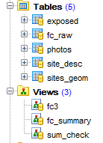

Table 2 Tables and views in the ground cover reference site database

|  |  |  |  |
| --- | --- | --- | --- |
| Name | Content for each site | Type | Attributes |
| exposed | Exposed ground cover fractions; bare, non-green (NPV) and green (PV) of sites | Table | Table 11 |
| fc_raw | Raw data for each point along the transect layout (200 or 300 observations) | Table | Table 3 |
| photos | An index of 7 or 5 photographs taken along the transect layout | Table | Table 4 |
| site_desc | Other information describing the site such as land use, vegetation species, soil surface condition, soil colour etc | Table | Table 5-7 |
| sites_geom | Location in latitude and longitude | Table(geom) | Table 8 |
| fc3 | Totals for the ground layer fractions green (PV), non-green (NPV) and BS (bare) fractions and ground cover (PV + NPV) (%) | View | Table 10 |
| fc_summary | Totals for each cover category (%) | View | Table 9 |
| sum_check | Total cover to identify errors (%) | View | Table 12 |

Note: PV—photosynthetic vegetation; NPV—non-photosynthetic vegetation; BS—bare soil

# Field collection protocols

The field collection protocol code from the site_desc table in the PostGIS database (Table 5) identifies the layout of the field transects and the attributes collected at the site. The data collected through the Ground cover monitoring for Australia project uses two transect layouts developed by Queensland Department of Science, Information Technology, Innovation and the Arts (Muir et al. 2011). Fractional ground cover data collected prior to this project used the same transect layouts but slightly different attributes. TERN AusPlots sites use a more intensive transect layout to collect fractional ground cover data as described at Appendix B. The different transect layouts described by the protocols below are all suitable for improving MODIS and Landsat fractional cover algorithms. The protocols have been assigned a code, beginning with P1 for Protocol 1. Each protocol is described below.

**P1:** The star-shaped transect method developed for the Queensland Statewide Land And Trees Survey (SLATS) has been used to measure vegetation in natural or pastoral environments (Figure 2). Three hundred points are measured using the star-shaped transect method as described in Muir et al. (2011).

Figure 2 P1 transect layout for natural or pastoral environments

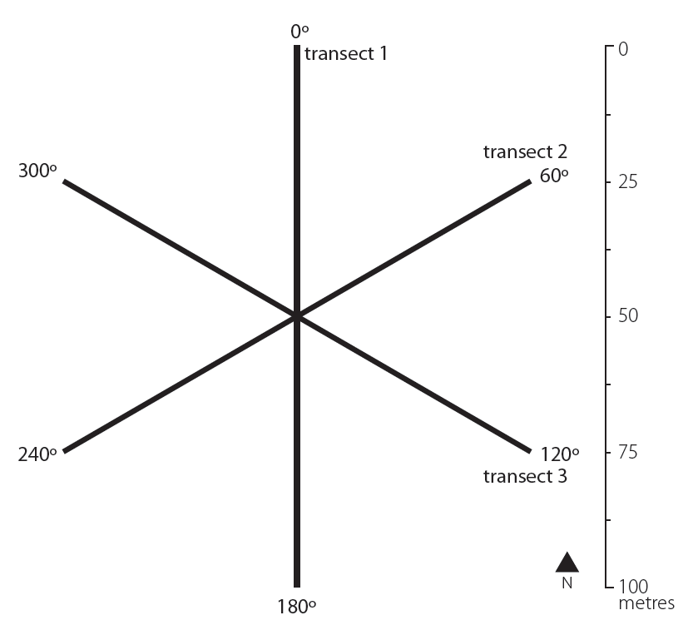

Source: Muir et al. (2011)

**P2:** The cross transect method has been adapted from the SLATS star-transect method as a simplified method for vegetation in rows, such as crops (Figure 3). Two hundred points are measured using the cross-shaped transect method as described in Muir et al. (2011).

Figure 3 P2 transect layout for vegetation in rows, such as agricultural crops

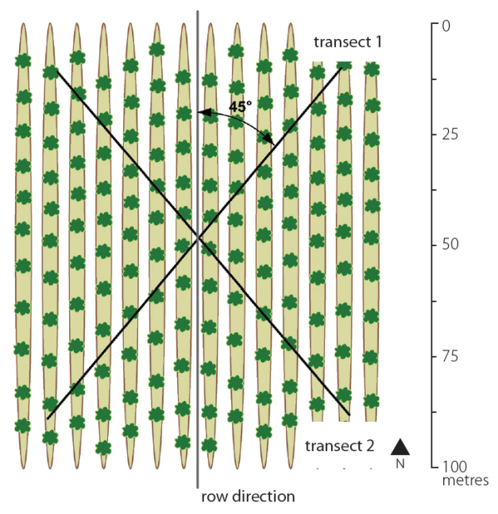

Source: Muir et al. (2011)

### Raw transect data

The fc_raw table (Table 3) contains multiple measurements taken at each site of the presence or absence of ground cover, woody vegetation less than two metres (midstorey) and woody vegetation greater than 2 metres (overstorey). For most sites a total of 300 observations of the vegetation at the site are taken, with one measurement taken every metre along three 100 metre transects arranged in a star-shape (P1) (Figure 2). Where vegetation is in rows, as for cropping, the pattern of cover is more uniform and the method has been simplified to a total of 200 observations recorded along two 100 metre transects oriented 45 degrees off-row (P2) (Figure 3) as described in the section above.

Measurements are recorded as a ‘1’. Only one feature type (i.e. green leaf, dry leaf etc) is recorded for each observation category (stratum), except where the measurement for woody vegetation greater than two metres is within a live tree crown, in this case two measurements are recorded, 'in crown' (field name: ‘oic’) as well as the canopy element intercepted.

Table 3 Attributes of fc_raw table

|  |  |  |  |  |
| --- | --- | --- | --- | --- |
| Field name | Description | Data type | Values allowed | Strata |
| point | Transect measurement | Integer | 1–300 | All |
| cr | Soil crust | Integer | 0, 1 | Ground |
| ds | Disturbed soil | Integer | 0, 1 | Ground |
| rk | Rock | Integer | 0, 1 | Ground |
| gr | Green leaf non-woody vegetation | Integer | 0, 1 | Ground |
| dr | Dry leaf non-woody vegetation | Integer | 0, 1 | Ground |
| li | Litter | Integer | 0, 1 | Ground |
| cy | Cryptogam | Integer | 0, 1 | Ground |
| mg | Green leaf woody vegetation <2m | Integer | 0, 1 | Mid |
| md | Dry leaf woody vegetation <2m | Integer | 0, 1 | Mid |
| mb | Branch <2m | Integer | 0, 1 | Mid |
| oic | In crown for live woody vegetation >2m | Integer | 0, 1 | Over |
| og | Green leaf woody vegetation >2m | Integer | 0, 1 | Over |
| od | Dry leaf woody vegetation >2m | Integer | 0, 1 | Over |
| ob | Branch >2m | Integer | 0, 1 | Over |
| unique_obs | Site identifier  (longitude_latitude_date) | Text | 00000000_0000000_yyyymmdd  32 characters | All |
| g_total | Only one observation for ground cover (cr+ds+rk+gr+dr+li+cy) is permitted at each point | Integer | 1 | Ground |
| m_total | Zero or one observations of woody vegetation <2m (mg+md+mb) are permitted at each point | Integer | 0, 1 | Mid |
| o_total | Zero, one or two observations of woody vegetation >2m (oic+og+od+ob) are permitted at each point. | Integer | 0, 1, 2 | Over |
| all_total | Number of strata for each transect point (g_total+m_total+o_total) | Integer | 1, 2, 3, 4 | All |

Note: Primary key = unique_obs, point. Non-woody vegetative cover, such as grasses, has no height restriction; dry leaf is senescent or dead vegetation attached to a plant or the ground; litter is unattached dead vegetation; cryptogam is a biological crust on the soil surface; in crown is the vertically projected perimeter of all foliage and branches of the plant and is recorded for live trees only. Latitude and longitude are given in decimal degrees.

### Photographs

Digital photographs are taken at each site. All images are taken from the transect centre, with the first pointing directly down (G) and the others along each transect line (L) starting at north and working around in a clockwise direction. Five photos are taken when the site has vegetation in rows (cropping) and seven photos at each site in natural or pastoral environments. The number of photos taken reflects the field collection protocol adopted—P2 or two transects for vegetation in rows (Figure 3) and P1 or three transects for natural or pastoral environments (Figure 2). The photos table (Table 4) stores the details of the digital photographs.

Table 4 Attributes of photos table

|  |  |  |  |
| --- | --- | --- | --- |
| Field name | Description | Data type | Values allowed |
| code | Primary key (unique_obs, name) | Text | 35 characters |
| unique_obs | Site identifier  (longitude_latitude_date) | Text | 00000000_0000000_yyyymmdd  32 characters |
| site_name | Name of the site e.g. Vic1001 | Text | 20 characters |
| state | State abbreviation e.g. NSW | Text | 3 characters |
| crop | Site cropped or not | Text | Yes, No |
| name | G1=centre down, L1=1st , L2=­2nd , L3=3rd, L4=4th, L5=5th, L6=6th | Text | G1, L1, L2, L3, L4, L5 , L6 |
| transect | Which transect the image shows | Integer | 1, 2, 3 |
| direction | Site orientation in degrees | Integer | 0-360 |
| cardinal_direction | Direction text | Text | 10 characters |

Note: At sites with vegetation in rows (cropping) only 5 photos were taken (G1, …, L4). Site photos can be viewed on the TERN AEKOS data portal (<http://www.aekos.org.au/home>).

### Site description

The site description details are saved in the table site_desc. In this user guide the site_desc attributes are presented in three tables corresponding to the three sections of the site description form used by the field operator to enter the data. Table 5 contains the basic site description attributes, Table 6 contains the vegetation description attributes and Table 7 contains the land surface attributes. Some site_desc table attributes—basic soil colours and soil moisture (Table 7)—have been calculated from the collected data.

Table 5 Attributes of site_desc table: basic site description

|  |  |  |  |
| --- | --- | --- | --- |
| Field name | Description | Data type | Values allowed |
| publish | Consent for public release of data (if ‘No’: not published) | Text | Yes, No |
| unique_obs | Site identifier  (longitude_latitude_date) | Text | 00000000_0000000_yyyymmdd  32 characters |
| site_name | Name of the site e.g. Vic1001 | Text | 20 characters |
| state | State abbreviation e.g. NSW | Text | 3 characters |
| loc_desc | Landform or nearby landmarks e.g. towns or roads – UNPUBLISHED | Text | 255 characters |
| site_desc | Details of land use, management or recent natural events | Text | 255 characters |
| date_collect | Date site completed as year, month, day | Integer | yyyymmdd |
| time | Time site started in 24 hour time | Time 5 | hh:mm |
| purpose | Purpose of data collection | Text | Ground cover monitoring |
| protocol | Code describing the transect layout and attributes collected | Text | P1, P2, P3, P4, P5 |
| revisit | If site has been observed previously using the same protocol | Text | Yes, No |
| zone | Zone as per MGA94 or UTM | Integer | 49–56 |
| datum | Coordinate system, WGS94 or GDA94 | Text | 6 characters |
| obs_collect | Person who made the transect readings – UNPUBLISHED | Text | 20 characters |
| obs_log | Person who recorded the transect readings -  UNPUBLISHED | Text | 20 characters |
| east_c | Transect centre easting | Real |  |
| north_c | Transect centre northing | Real |  |
| diff_gps | Whether a differential GPS was used for a more accurate location | Text | Yes, No |
| bear_t1,2,3 | Bearing of transect 1, 2 and 3 in degrees | Integer | 0–360 |
| slope | Slope of site in per cent | Integer | 0–100 |
| aspect | Horizontal direction in which the slope faces in degrees | Integer | 0–360 |
| landuse | ALUM v7 tertiary class | Text | 50 characters |
| alumv7 | ALUM v7 tertiary code, no decimals e.g. 331 | Integer | 100–663 |
| commod | Commodity name | Text | 20 characters |
| crop | Site cropped or not | Text | Yes, No |
| management | The current management phase for the vegetation present, including litter (interpreted with growth stage) | Text | Abandoned, Baled, Burnt, Cultivated, Grazed, Incorporated, Mulched, Sprayed, Standing/none, Other |
| growth | Growth phase for the majority of plants observed | Text | Establishment, Immature/growing, Mature, Senescence/residue, None |
| spectra | Whether field spectra collected | Text | Yes, No |

Note: See field protocols section for descriptions of protocols. ALUM v7 is the Australian Land Use and Management Classification ([www.daff.gov.au/abares/aclump](http://www.daff.gov.au/abares/aclump)). Unpublished data (see description: ‘UNPUBLISHED’) has been excluded from the dataset.

Table 6 Attributes of site_desc table: vegetation description

|  |  |  |  |
| --- | --- | --- | --- |
| Field name | Description | Data type | Values allowed |
| biomass | Estimate of standing non-woody ground cover biomass (kg/ha) | Real |  |
| biomass_method | Method used to estimate biomass density | Text | Visual, Photo standards,  Visual and photo standards, Quantitative |
| grass_m | Average non-woody vegetation height (m) | Real |  |
| fire | Recent or severe fire | Text | 0 - No evidence,  1 - Minor burn (<5% site or >3 years),  2 - Recent/major burn (>5% site or <3 years) |
| perm_veg | Percentage of perennial grass cover | Text | 0-5%, 6-25%, 26-50%, 51‑75%, 76-100% |
| overstorey | Average woody vegetation height (m) | Real |  |
| veg1st_o, 2nd, 3rd | Dominant 3 species by biomass for woody vegetation >2m | Text | 55 characters |
| veg1stpc_o, 2nd, 3rd | Occurrence by biomass of the 3 dominant woody vegetation >2m species (%) | Real | 0–100.00 |
| veg1st_m, 2nd, 3rd | Dominant 3 species by biomass for woody vegetation <2m | Text | 55 characters |
| veg1stpc_m, 2nd, 3rd | Occurrence by biomass of the 3 dominant woody vegetation <2m species (%) | Real | 0–100.00 |
| veg1st_g, 2nd, 3rd | Dominant 3 species by biomass for the non-woody ground layer | Text | 55 characters |
| veg1stpc_g | Occurrence by biomass of the 3 dominant non-woody species (%) | Real | 0–100.00 |
| prism1, 2, 3, 4, 5, 6, 7 | Prism factor used for tree basal area at each of 7 points on the transects | Real |  |
| live1, 2 ,3 ,4 ,5 , 6, 7 | Number of live trees inside area at each of 7 points on the transect | Integer |  |
| dead1,2,3,4,5,6,7 | Number of dead trees inside area at each of 7 points on the transect | Integer |  |
| conv1, 2, 3, 4, 5, 6, 7 | Converted (prism x live) | Real |  |
| total_live | Average (live) tree basal area (total conv / 7) (m2/ha) | Real |  |

Table 7 Attributes of site_desc table: land surface

|  |  |  |  |
| --- | --- | --- | --- |
| Field name | Description | Data type | Values allowed |
| erosion | State of erosion | Text | N - None, A - Active, S - Stabilised, P – Partly stabilised |
| wind_erosion | Wind erosion severity | Text | 0 - None, 1 - Minor, 2 - Moderate, 3 - Severe, 4 - Very severe |
| scald_erosion | Scald erosion by water and/or wind severity | Text | 0 - None, 1 - Minor (<5% of site), 2 - Moderate (5-50% of site), 3 - Severe (>50% of site) |
| sheet_erosion | Sheet erosion by water severity | Text | 0 - None, 1 - Minor, 2 - Moderate, 3 - Severe |
| rill_erosion | Rill erosion by water severity | Text | 0 - None, 1 - Minor (occasional), 2 - Moderate (common), 3 - Severe (corrugated) |
| gully_erosion | Gully erosion by water severity | Text | 0 - None, 1 - Minor (isolated), 2 - Moderate (restricted to drainage lines), 3 - Severe (branch away from primary drainage lines) |
| deposits | Deposited materials | Text | Sand (<2mm), Gravel (2-60mm), Stones (>60mm) |
| amount | Abundance of deposited material | Text | 0 - None, 1 - Very few (<2%), 2 - Few (2-10%), 3 - Common (10-20%), 4 - Many (20-50%), 5 - Abundant (50-90%), 6 - Very abundant (>90%) |
| micro_relief | Surface smoothness, mounds, depressions, furrows | Text | 0 - Smooth (<3 mm variation), D - Depressions, M - Mounds, C - Cropping rows/furrows |
| vertical_m | Interval between base and crest (m) | Integer |  |
| horizontal_m | Horizontal distance between crests (m) | Integer |  |
| s_cond1, 2, 3 | Surface condition when dry | Text | G - Cracking, M - Self-mulching, L - Loose, S - Soft, F - Firm, H - Hard setting, C - Surface crust, X - Surface flake, Y - Cryptogam surface, T - Trampled, P - Poached, R - Recently cultivated, Z - Saline, O - Other |
| s_stngth | Surface soil strength | Text | 0 - Loose, 1 - Very weak, 2 - Weak, 3 - Firm, 4 - Very firm, 5 - Strong, 6 - Very strong, 7 - Rigid |
| s_cracks | Surface cracks | Text | 1 – Fine (<5 mm), 2 – Medium (5-10 mm), 3 – Coarse (10-20 mm), 4 - Very coarse (20-50 mm), 5 - Extremely coarse (>50 mm) |
| disturb1, 2, 3 | Biotic agents causing soil surface relief disturbance (up to 3 agents) | Text | NH - Horses, NS - Sheep, NC - Cows, NG - Goats, NP - Pigs, NM - Macropod, NL - Camel, NR - Rabbits, H - Human, B - Bird, T - Termite, A - Ant, V - Vegetation, O - Other |
| crust_d/w_h | Dry and wet soil crust colour (Munsell hue) | Text |  |
| crust_d/w_v | Dry and wet soil crust colour (Munsell value) | Integer |  |
| crust_d/w_c | Dry and wet soil crust colour (Munsell chroma) | Integer |  |
| dist_d/w_h | Dry and wet disturbed soil colour (Munsell hue) | Text |  |
| dist_d/w_v | Dry and wet disturbed soil colour (Munsell value) | Integer |  |
| dist_d/w_c | Dry and wet disturbed soil colour (Munsell chroma) | Integer |  |
| crypto | Cryptogam cover (%) | Text | None, <2%, 2-10%, 10-20%, 20-50%, 50-90%, >90% |
| crypto_mc | Cryptogam colour (Munsell hue, value, chroma) | Text | 50 characters e.g. 5YR 3/2 |
| crypto_bc | Cryptogam colour (basic colour) | Text | 50 characters |
| crypto_w_d | Cryptogam wet or dry | Text | Wet, Dry |
| rock1st, 2nd, 3rd_h | First three dominant rock cover readings (Munsell hue) | Text |  |

Table 7 (cont.) Attributes of site_desc table: land surface

|  |  |  |  |
| --- | --- | --- | --- |
| Field name | Description | Data type | Values allowed |
| rock1st, 2nd, 3rd_v | Rock colour for dominant 3 (Munsell value) | Integer |  |
| rock1st, 2nd, 3rd_c | Rock colour for dominant 3 (Munsell chroma) | Integer |  |
| rock_lag | Abundance of rocks/lag (%) | Text | 0 - None, 1 - Very few (<2% of site), 2 - Few (2-10% of site), 3 - Common (10-20% of site), 4 - Many (20-50% of site), 5 - Abundant (50-90% of site), 6 - Very abundant (>90% of site) |
| rock_lag_s | Average fragment size | Text | Fine gravelly (2-6 mm), Medium gravelly (6-20 mm), Coarse gravelly (20-60 mm), Cobbly (60-200 mm), Stony (200-600 mm), Boulders (60-2000 mm), Large boulders (>2000 mm) |
| soilclr1_cd | Basic colour for dry soil crust | Text | Yellow, Red, Brown, Black, Grey |
| soilclr2_dd | Basic colour for dry disturbed soil | Text | Yellow, Red, Brown, Black, Grey |
| soilclr3_cw | Basic colour for wet soil crust | Text | Yellow, Red, Brown, Black, Grey |
| soilclr4_dw | Basic colour for wet disturbed soil | Text | Yellow, Red, Brown, Black, Grey |
| soil_col_max | Most represented soil colour | Text | Yellow, Red, Brown, Black, Grey, Null |
| wet_dry | Whether a dry soil colour was given | Text | Dry, Null, Wet |

Note: Soil and rock/lag colour are recorded using the Munsell Soil Color Charts (1994). Basic soil colour is derived from the Munsell Soil Color Charts according to the colour classes of the Australian Soil Classification (Isbell 2002) ([www.clw.csiro.au/aclep/asc_re_on_line/soilcocl.htm](http://www.clw.csiro.au/aclep/asc_re_on_line/soilcocl.htm)). Most represented soil colour is determined from the frequency of transect observations for soil crust and disturbed soil from fc_raw (Table 3). The soil surface is assumed to have been wet when visited if there is no dry soil colour recorded.

### Site locations

The x, y coordinates of the field locations are saved in the sites_geom table (Table 8). This table contains geometries to enable the field locations to be shown and queried spatially in geographic information system programs such as QGIS.

Table 8 Attributes of sites_geom table

|  |  |  |  |
| --- | --- | --- | --- |
| Field name | Description | Data type | Values allowed |
| site_name | Name of the site e.g. Vic1001 | Text | 20 characters |
| state | State abbreviations e.g. NSW | Text | 5 characters |
| latitude | Latitude | Real |  |
| longitude | Longitude | Real |  |
| unique_obs | Site identifier  (longitude_latitude_date) | Text | 00000000_0000000_yyyymmdd  32 characters |
| geom | Point geometry (latitude, longitude in WGS84) | Point location |  |

### Cover summaries

Views are automatically updated as data is added or changed in the other tables. The views fc_summary (Table 9) and fc3 (Table 10) calculate fractions for the ground layer from the raw transect values in fc_raw (Table 3). Other views could be produced to calculate total vegetation cover including the woody vegetation components (such as view sum_check; Table 12).

The view fc_summary (Table 9) calculates the percent cover for each cover type directly from the 200 or 300 transect observations (points) recorded in the table fc_raw.

Table 9 Attributes of fc_summary view

|  |  |  |  |
| --- | --- | --- | --- |
| Field name | Description | Data type | Values allowed |
| crust | Soil crust (%) = (sum cr / no. points) x 100 | **Real** | 0–100.00 |
| dist | Disturbed soil (%) = (sum ds / no. points) x 100 | **Real** | 0–100.00 |
| rock | Rock (%) = (sum rk / no. points) x 100 | **Real** | 0–100.00 |
| green | Green leaf non-woody vegetation (%) = (sum gr / no. points) x 100 | **Real** | 0–100.00 |
| dry | Dry leaf non-woody vegetation (%) = (sum dr / no. points) x 100 | **Real** | 0–100.00 |
| litter | Litter (%) = (sum li / no. points) x 100 | **Real** | 0–100.00 |
| crypto | Cryptogam (%) = (sum cy / no. points) x 100 | **Real** | 0–100.00 |
| mid_g | Green leaf woody vegetation <2m (%) = (sum mg / no. points) x 100 | **Real** | 0–100.00 |
| mid_d | Dry leaf woody vegetation <2m (%) = (sum md / no. points) x 100 | **Real** | 0–100.00 |
| mid_b | Branch <2m (%) = (sum mb/ no. points) x 100 | **Real** | 0–100.00 |
| in_crown | In live tree crown (%) = (sum oic/ no. points) x 100 | Real | 0–100.00 |
| over_g | Green leaf woody vegetation >2m (%) = (sum og/ no. points) x 100 | **Real** | 0–100.00 |
| over_d | Dry leaf woody vegetation >2m (%) = (sum od / no. points) x 100 | **Real** | 0–100.00 |
| over_b | Branch >2m (%) = (sum ob / no. points) x 100 | **Real** | 0–100.00 |
| unique_obs | Site identifier  (longitude_latitude_date) | Text | 00000000_0000000_yyyymmdd  32 characters |

### Cover fractions

The view fc3 (Table 10) calculates the three ground cover fractions by adding the field calculated in the view fc_summary (Table 9).

Table 10 Attributes of fc3 view

|  |  |  |  |
| --- | --- | --- | --- |
| Field name | Description | Data type | Values allowed |
| **bare** | **Bare soil (BS) (%)**  **= (crust + dist + rock + crypto)** | **Real** | 0–100.00 |
| **green** | **Photosynthetic non-woody vegetation (PV) (%)**  **= green** | **Real** | 0–100.00 |
| **brown** | **Non-photosynthetic non-woody vegetation (NPV)(%) = dry + litter** | **Real** | 0–100.00 |
| **cover** | Non-woody ground cover (PV + NPV) (%) = green + brown | **Real** | 0–100.00 |
| **unique_obs** | Site identifier  (longitude_latitude_date) | Text | 00000000_0000000_yyyymmdd  32 characters |

### Exposed cover fractions

The table exposed (Table 11) presents the three cover fractions calculated from all vegetation strata – ground, mid, and overstorey. Exposed cover is the first cover seen when looking down on the transect point and estimates the view seen by the satellite. Exposed cover differs from the fc3 calculated cover as fc3 presents the ground cover by calculating the cover fractions only for non woody vegetation, bare soil and litter and excludes woody vegetation <2m and woody vegetation >2m (Table 10). The calculation of exposed cover is currently completed in Microsoft Excel however this table could be improved by calculating exposed cover as a view so it automatically updates as new observations are added.

Table 11 Attributes of exposed table

|  |  |  |  |
| --- | --- | --- | --- |
| Field name | Description | Data type | Values allowed |
| **unique_obs** | Site identifier  (longitude_latitude_date) | Text | 00000000_0000000_yyyymmdd  32 characters |
| **ex_bare** | **Exposed bare soil (BS)(%) = (crust + dist + rock + crypto) where no mid or overstorey** | **Real** | 0–100.00 |
|  |  |  |  |
| **ex_brown** | **Exposed non-green or non-photosynthetic vegetation (NPV) (%) = ob, od, mb, md, dry or litter** | **Real** | 0–100.00 |
| **ex_green** | **Exposed green or photosynthetic vegetation (PV) (%) = og, mg or green** | **Real** | 0–100.00 |
| **points** | **Number of point intercept observations** | **Integer** | 0-300 |

The exposed cover is calculated for each transect point. A pivot table is then used to calculate the percentage exposed cover for the site. For each transect point the exposed cover is the overstorey cover fraction, unless there is no overstorey fraction then it is the midstorey fraction, unless there is no midstorey, then it is the ground cover fraction. The overstorey and midstorey are calculated as green, brown, or absent using the following calculations:

mid = IF(mid green mg=1,"green", IF(mid dry md=1, "brown", IF(mid branch mb=1, "brown", 0))) over =IF(over green og=1,"green", IF(over dry od=1, "brown", IF(over branch ob=1, "brown", 0)))

The ground cover is calculated as green, brown or bare using the following calculation:

ground=IF(crust =1,"bare", IF(disturbed=1,"bare", IF(rock=1,"bare", IF(green=1,"green",IF(dry=1,"brown",IF(litter=1,"brown",IF(crypto=1,"bare",0)))))))

The exposed cover for the point is calculated as:

exposed=IF(over="green", "green",IF(over="brown","brown",IF(mid="green", "green",IF(mid="brown","brown", ground))))

### Checking the data

The view sum_check (Table 12) calculates the cover fraction percentages for each site at the ground layer, woody vegetation <2m layer (midstorey) and woody vegetation >2m layer (overstorey). The ground layer percentage should equal 100 percent as a fraction is recorded at each transect intercept (observation). The woody vegetation <2m (midstorey) and woody vegetation >2m (overstorey) layers do not have values collected at every transect intercept. When woody vegetation >2m is encountered in a live tree crown two values are recorded. ‘In crown’ indicates that the transect falls in an area of live tree canopy, and the second value recorded describes the cover fraction encountered. Overstorey transect intercepts in sites with live tree canopy present may add up to 200. Sites suitable for collecting ground cover information are however chosen based on less than 20 per cent foliage projective cover and therefore the overstorey intercepts should be less than 100.

Table 12 Attributes of sum_check view

|  |  |  |  |
| --- | --- | --- | --- |
| Field name | Description | Data type | Values allowed |
| unique_obs | Site identifier  (longitude_latitude_date) | Text | 00000000_0000000_yyyymmdd  32 characters |
| ground | Intercepts with a value for ground layer (%) | Real | 100.00 |
| mid | Intercepts with a value for woody vegetation <2m (%) | Real | 0–100.00 |
| over | Intercepts with a value for woody vegetation >2m (%) | Real | 0–200.00 |
| total | Sum of all observations (%)  (ground + mid + over) | Real | 100.00–400.00 |

# SQL functions

### Querying the database

Example SQL functions to query the PostGIS field database (table name, field name or threshold values can be changed as desired):

* Select all raw transect points for a particular site (change table name or field as desired)

SELECT *FROM fc_raw WHERE "unique_obs" = '14885344_3205411_20101125';

* Select only some columns from a table

SELECT photos.code,photos.crop FROM photos;

* Select sites with bare (crust, disturbed, rock, crypto) greater than 40 per cent

SELECT * FROM fc3 WHERE (cast(bare as double precision)>40);

* Select sites with bare excluding crypto (crust, disturbed, rock) greater than 40 per cent

SELECT * FROM fc_sum WHERE (cast (dist as double precision)+cast(cr as double precision)+cast(rock as double precision)>40);

* Select site name and collection date for sites with active erosion

SELECT erosion,site_name,date_collect,time FROM site_desc WHERE erosion LIKE ('A%');

* Join two tables on unique_obs and select all bare, brown and green fractions and site name and collection date and time for sites with active erosion

SELECT fc3.*, site_desc.erosion, site_desc.site_name, site_desc.date_collect, site_desc.time FROM fc3,site_desc WHERE erosion LIKE ('A%') AND fc3.unique_obs=site_desc.unique_obs;

* Summarise data by a column (number of sites per state)

SELECT state, COUNT(*) FROM site_desc GROUP BY state;

* Select metrics and summarise by a column (bare—maximum, minimum, average by state)

SELECT state, MAX(bare), MIN(bare), AVG(bare) FROM site_desc, fc3 WHERE site_desc.unique_obs=fc3.unique_obs GROUP BY state;

* Summarise data by 2 columns (states, cropping)

SELECT state, crop, COUNT(*) FROM site_desc GROUP BY state, crop ORDER BY 1, 2;

### Manipulating the database

Example SQL functions to manipulate the PostGIS field database:

* Create a copy of an existing table  
  CREATE TABLE fc_raw_backup AS SELECT * FROM fc_raw;

INSERT into gcov_pub.fc_raw SELECT * from gcov.fc_raw;

* Change a column name

ALTER TABLE photos RENAME COLUMN direction TO dir;

* Insert a row of values into a table

1. landsat table

INSERT INTO landsat VALUES ('13426837_2887273_20110416_1','13426837_2887273_20110416','1','LT51010802011085ASA00.tar.gz','0');

1. photos table

INSERT INTO photos (code,unique_obs,site_name,state,crop,name,transect,direction) VALUES ('10000000_1000000_20110101_g1','10000000_1000000_20110101','sitename','NSW','n','g1','00','00');

* Delete a row from a table

DELETE FROM photos WHERE code='10000000_1000000_20110101_g1';ALTER TABLE photos DROP ROW yel

* Delete column (a whole table can also be dropped)

ALTER TABLE table_name DROP COLUMN column_name

* Delete from a table based on an attribute in another table

DELETE from gcov_pub.fc_raw WHERE unique_obs in (select unique_obs from gcov.site_desc where publish = ‘No’);

* Update data in a column based on an existing attribute

1. Replace an existing value with a new one

UPDATE exposed set "unique_obs" = '12172062_3086876_20101013' where "unique_obs" = '12172062_3086876_20101213';

1. Add a new geometry location

UPDATE sites_geom set geom = geomfromtext('Point (-36.836742 143.96555)' ,4326) where site_name = 'vic002';

# Appendix A. Other fractional cover reference site data

The Australian ground cover reference sites database, as described in this user guide, contains only published data. Field observations of fractional cover which are unpublished or collected outside of the Ground cover monitoring for Australia project are also available to calibrate and validate fractional cover products derived from the Landsat and MODIS satellites. Appendix A describes the larger database of all 1714 observations from 1259 unique sites provided to ABARES as at August 2014. Map A1 shows the breakdown of these field sites by provider. Table A1 gives the total number of sites collected for the Ground cover monitoring for Australia project and by other sources. Table A2 provides the organisation and date of collection for site data delivered under the Ground cover monitoring for Australia project, while Table A2 gives the same information for the additional site data available for validation.

Map A1 Ground cover sites in the database (as at August 2014)

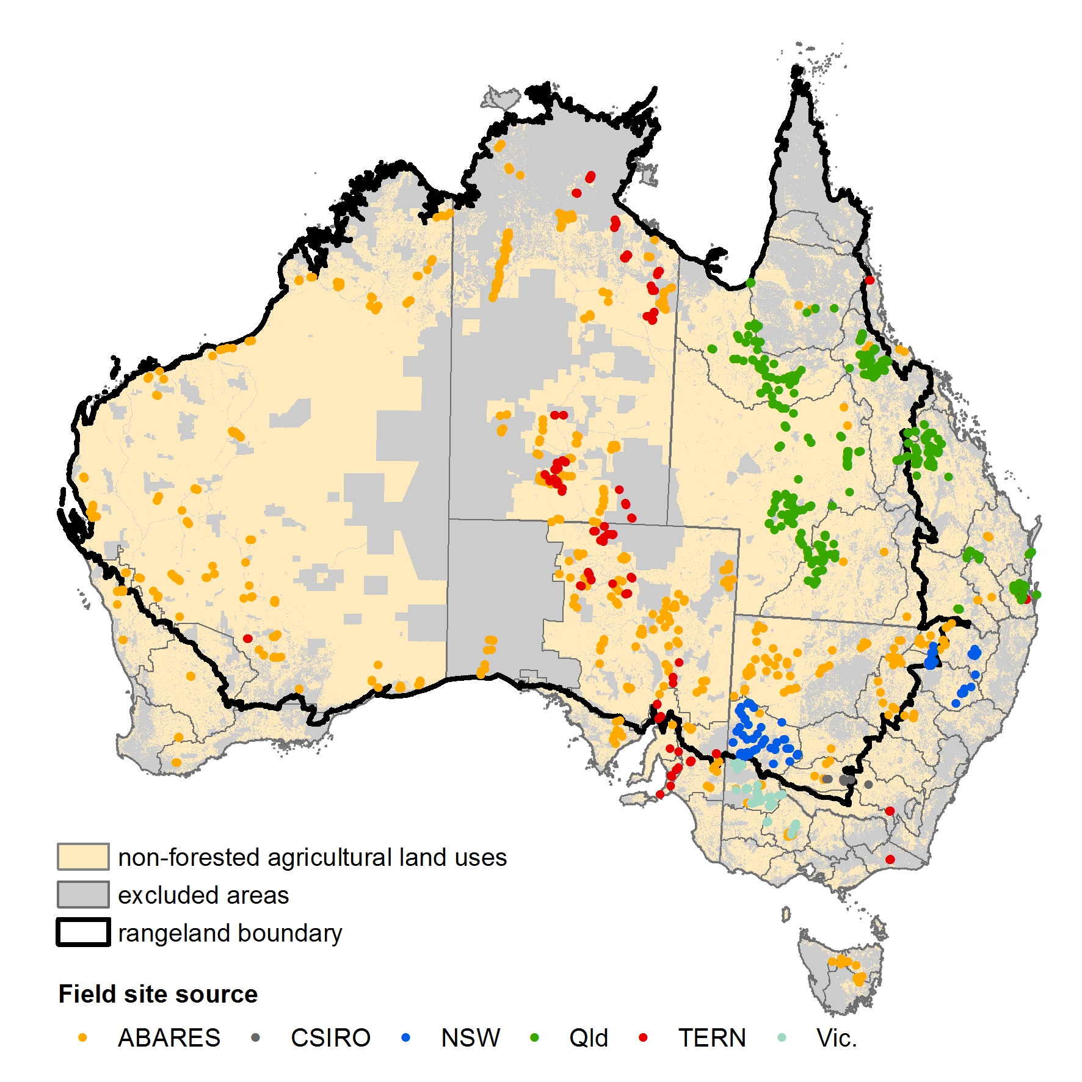

Note: Sources of sites data are: ABARES funded by Department of Agriculture through the Ground cover monitoring for Australia project; CSIRO Commonwealth Scientific and Industrial Research Organisation; NSW Lower Murray-Darling and Namoi Catchment Management Authorities; Qld Queensland Remote Sensing Centre; TERN Terrestrial Ecosystem Research Network AusCover Supersites and AusPlots (rangelands) sites; Vic. Victorian Department of Environment and Primary Industries.

Source***:*** ABARES

**Table A1. Total number of sites and observations**

|  |  |  |  |  |
| --- | --- | --- | --- | --- |
|  | **Number of sites (observations)** | | | |
| **Source** | **Total** | **Rangelands** | **Intensive land use zone** | **Cropping** |
| Ground cover monitoring for Australia | 596 (643) | 437 (441) | 159 (202) | 156 |
| Other sources | 422 (631) | 277 (355) | 145 (276) | 0 |
| **Total** | **1259 (1714)** | **935 (1169)** | **324 (545)** | **156** |

**Table A2. Number of sites and observations collected though the Ground cover monitoring for Australia project**

|  |  |  |  |  |  |  |  |
| --- | --- | --- | --- | --- | --- | --- | --- |
|  |  | **Data collected** | | **Number of sites (observations)** | | | |
| **State** | **Source** | **Year** | **Month** | **Total** | **Rangelands** | **Intensive land use zone** | **Cropping** |
| NSW | Training | 2010 | Nov | 5 | 0 | 5 | 1 |
|  | OEH | 2011 | April, June, July | 44 | 41 | 3 | 7 |
|  |  | 2012 | April, Aug, Oct | 42 | 39 | 3 | 6 |
| NT | Training | 2011 | May | 5 | 5 | 0 | 2 |
|  | LRM | 2011 | Aug–Oct | 36 | 36 | 0 | 0 |
|  |  | 2012 | Feb–Aug | 68 | 68 | 0 | 0 |
|  |  | 2014 | May | 9 | 9 | 0 | 0 |
| Qld | DSITIA | 2011 | June–Sept, Nov | 16 (17) | 4 | 12 (13) | 3 |
|  |  | 2012 | April–June, Oct | 9 (13) | 9 (13) | 0 | 0 |
| SA | Training | 2010 | July | 6 | 4 | 2 | 2 |
|  | DEWNR | 2011 | April, May | 39 | 34 | 5 | 7 |
|  |  | 2012 | March, April, Nov, Dec | 55 | 48 | 7 | 8 |
|  |  | 2014 | May | 9 | 9 | 0 | 0 |
| Tas. | Training | 2011 | March, April | 4 | 0 | 4 | 1 |
|  | DPIPWE | 2011 | Dec | 2 | 0 | 2 | 0 |
|  |  | 2012 | June, Dec | 18 | 0 | 18 | 12 |
|  |  | 2013 | Feb | 1 | 0 | 1 | 0 |
| Vic. | Training | 2011 | March | 5 | 0 | 5 | 2 |
|  | DEPI | 2012 | Jan, Feb | 22 | 0 | 22 (23) | 15 |
|  | * | 2012 | Jan, Feb, April, May | 15 (30) | 0 | 15(30) | 13 (23) |
|  |  | 2013 | Jan | 19 | 0 | 19 (20) | 14 (15) |
|  | * | 2014 | Jan, Feb, April, May | 16 (41) | 0 | 16 (41) | 16 (40) |
| WA | Training | 2010 | Oct | 9 | 6 | 3 | 3 |
|  | DAF | 2011 | May, July–Oct | 50 | 43 | 7 | 7 |
|  |  | 2012 | June–Sept, Nov | 83 | 73 | 10 | 2 |
|  |  | 2014 | June | 9 | 9 | 0 | 0 |
|  |  |  | **Tota**l | **596 (643)** | **437 (441)** | **159 (202)** | **121 (156)** |

Note: OEH NSW Office of Environment and Heritage; LRM NT Department of Land Resource Management; DSITIA Queensland Department of Science, Information Technology, Innovation and the Arts; DEWNR South Australian Department of Environment, Water and Natural Resources; DEPI. Victorian Department of Environment and Primary Industries (*71 extra observations were funded by DEPI); DAF Western Australian Department of Agriculture and Food. Source: ABARES

**Table A3. Number of sites and observations collected by other sources**

|  |  |  |  |  |  |  |  |
| --- | --- | --- | --- | --- | --- | --- | --- |
|  |  | **Data collected** | | **Number of sites (observations)** | | | |
| **Source** | **State** | **Year** | **Month** | **Total** | **Rangelands** | **Intensive land use zone** | **Cropping** |
| RSC | Qld | 1997 | Feb, Sept, Oct | 36 (53) | 35 (51) | 1 (2) | n/a |
|  |  | 1998 | Feb | 2 (50) | 2 (48) | 0 (2) | n/a |
|  |  | 2002 | July, October | 73 | 73 | 0 | n/a |
|  |  | 2003 | April | 65 | 65 | 0 | n/a |
|  |  | 2004 | May, April, Oct, Nov, Dec | 55 (94) | 46 (78) | 9 (16) | n/a |
|  |  | 2005 | Jan, March, April, May, Aug–Nov | 10 (105) | 0 (58) | 10 (47) | n/a |
|  |  | 2006 | Feb, April–June, Aug–Oct | 53 (105) | 4 (35) | 49 (70) | n/a |
|  |  | 2007 | May | 7 | 0 | 7 | n/a |
|  |  | 2008 | June, July, Oct–Dec | 39 ( 66) | 31 (52) | 8 (14) | n/a |
|  |  | 2009 | April, May, July–Oct | 45 (55) | 32 (34) | 13 (21) | n/a |
|  |  | 2010 | Feb–Dec | 11 (61) | 0 | 11 (61) | n/a |
|  |  | 2011 | May–Dec | 3 (46) | 3 (5) | 0 (41) | n/a |
|  |  | 2012 | Jan, Feb | 4 (9) | 0 | 4 (9) | n/a |
| CMAs | NSW | 2009 | April, May | 32 | 32 | 0 | n/a |
|  |  | 2011 | March–June | 17 (37) | 17 (37) | 0 | n/a |
|  |  | 2012 | March–June | 39 | 18 | 21 | n/a |
| CSIRO | NSW | 2010 | Aug–Oct | 13 (14) | 12 (13) | 1 | n/a |
| AusCover | NSW | 2010 | Nov | 1 | 0 | 1 | 0 |
|  | NSW | 2011 | Jan | 4 | 0 | 4 | 0 |
|  | SA | 2012 | Jan, Feb | 6 | 6 | 0 | 0 |
|  | Vic. | 2012 | April | 5 | 0 | 5 | n/a |
|  | WA | 2012 | May | 8 | 8 | 0 | n/a |
|  | Qld | 2013 | Jan, Feb | 8 | 0 | 8 | n/a |
| AusPlots | NT | 2011 | Sept–Dec | 22 | 22 | 0 | 0 |
|  | NT | 2012 | Jan–Sept | 57 (58) | 57 (58) | 0 | 0 |
|  | SA | 2011 | June | 5 | 0 | 5 | 0 |
|  | SA | 2012 | June–Nov | 43 | 35 | 8 | 0 |
|  |  |  | **Total** | **422 (631)** | **277 (355)** | **145 (276)** | **0** |

Note: RSC Queensland Remote Sensing Centre; CMAs NSW Catchment Management Authorities; CSIRO Commonwealth Scientific and Industrial Research Organisation; Terrestrial Ecosystem Research Network AusCover Supersites and AusPlots (rangelands) sites.

Source: ABARES

## Fractional cover observations

From the field observations of fractional ground cover the three fractions; bare soil, non-green (or non-photosynthetic) vegetation, and green (photosynthetic) vegetation can be calculated. The distribution of the fractional ground cover observations are shown in Figure A1. This tri-plot shows the spread of observations across the possible cover fractions. There are fewer observations with low (<10%) non-green vegetation in conjunction with high (>90%) bare soil, however this is likely to be a naturally rare combination.

Figure A1 Distribution of green vegetation, non-green vegetation and bare soil ground cover fractions across the field observations

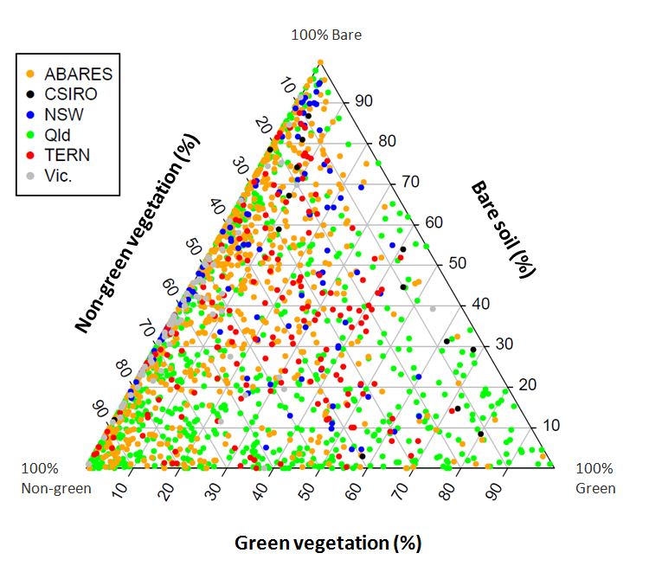

Note: Colours represent data source: ABARES funded by Department of Agriculture through the Ground cover monitoring for Australia project; CSIRO Commonwealth Scientific and Industrial Research Organisation; NSW New South Wales Lower Murray-Darling and Namoi Catchment Management Authorities; Qld Queensland Remote Sensing Centre; TERN Terrestrial Ecosystem Research Network AusCover Supersites and AusPlots (rangelands) sites; Vic. Victorian Department of Environment and Primary Industries. Number of observations is 1714.

Source: ABARES

Exposed fractional cover could be calculated for 741 of the total 1714 observations where the raw point intercept data was provided to ABARES, rather than just the summarised ground cover fractions. Exposed cover is an estimate of the first cover viewed by the satellite – overstorey when present, midstorey if no overstorey present and ground cover when no mid or overstorey. Exposed cover is shown in Figure A2.

Figure A2 Distribution of green vegetation, non-green vegetation and bare soil exposed cover fractions across the field observations

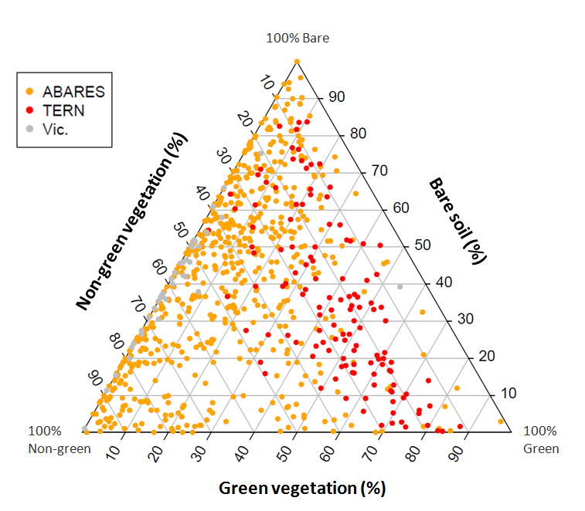

Note: Colours represent data source: ABARES funded by Department of Agriculture through the Ground cover monitoring for Australia project; TERN Terrestrial Ecosystem Research Network; Vic. Victorian Department of Environment and Primary Industries. Number of observations is 741.

Source: ABARES

## Data collection

The number of observations collected in each month of the year, and for each year between 1997 and 2014, are shown at Figure A3 and A4. Observations have been collected throughout the year though data collection has tended to occur more during the months of April to October. The ABARES Ground cover monitoring for Australia project began in 2010 with a small number of training sites. The majority of observations were collected in 2011 and 2012. Prior to 2010, field observations were collected by the Queensland Remote Sensing Centre (now within the Department of Science, Information Technology, Innovation and the Arts) and by the New South Wales Lower Murray-Darling Catchment Management Authority.

**Figure A3. Data collection by month**

Note: Colours represent data source: ABARES funded by Department of Agriculture through the Ground cover monitoring for Australia project; CSIRO Commonwealth Scientific and Industrial Research Organisation; NSW Lower Murray-Darling and Namoi Catchment Management Authorities; Qld Queensland Remote Sensing Centre; TERN Terrestrial Ecosystem Research Network AusCover Supersites and AusPlots (rangelands) sites; Vic. Victorian Department of Environment and Primary Industries.

Source: ABARES

**Figure A4. Data collection by year**

Note: Colours represent data source: ABARES funded by Department of Agriculture through the Ground cover monitoring for Australia project; CSIRO Commonwealth Scientific and Industrial Research Organisation; NSW Lower Murray-Darling and Namoi Catchment Management Authorities; Qld Queensland Remote Sensing Centre; TERN Terrestrial Ecosystem Research Network AusCover Supersites and AusPlots (rangelands) sites; Vic. Victorian Department of Environment and Primary Industries.

Source: ABARES

# Appendix B. Translation of TERN AusPlots fractional cover reference site data

As at June 2014 TERN AusPlots (rangelands) had published data from 129 observations (128 unique sites) on the Soils to Satellite (<http://www.soils2satellites.org.au>) and AEKOS websites (<http://www.portal.aekos.org.au/home>). More observational data will be published. Appendix B describes the procedure used to translate the TERN AusPlots (rangelands) point intercept observations into vegetation cover fractions to use in calibration or validation of remotely sensed fractional cover.

The point intercept method adopted by TERN AusPlots (rangelands) includes a 100 metre by 100 metre grid of five north-south transects and five east-west transects resulting in 1010 points (White et. al. 2012) (Figure B1).

Figure B1. TERN AusPlots grid transect layout for rangeland environments

Source: White et al. (2012)

AusPlots (rangelands) transect measurements are different to the Ground cover monitoring for Australia protocol (Muir et al 2011) due to:

1. No separation of crust and disturbed soil—both are combined into bare
2. No distinction between green and dry attached vegetation (or branch)—vegetation is labelled as alive or dead
3. No strata distinction—all vegetation in the intercept is recorded by height rather than a single intercept for each strata of ground, mid and overstorey.

These differences are summarised in Table B1.

**Table B1. Cover fractions collected by Ground cover monitoring for Australia and AusPlots (rangelands) protocols**

|  |  |  |  |  |  |  |  |  |  |  |  |  |  |  |
| --- | --- | --- | --- | --- | --- | --- | --- | --- | --- | --- | --- | --- | --- | --- |
|  | **CRUST** | **DISTURBED** | **ROCK** | **GREEN LEAF** | **DRY LEAF** | **LITTER** | **CRYPTOGAM** | **<2M GREEN LEAF** | **<2M DRY LEAF** | **<2M BRANCH** | **IN CROWN** | **>2M GREEN LEAF** | **>2M DRY LEAF** | **>2M BRANCH** |
| **GCM4A** | 1/0 | 1/0 | 1/0 | 1/0 | 1/0 | 1/0 | 1/0 | 1/0 | 1/0 | 1/0 | 1/0 | 1/0 | 1/0 | 1/0 |
| **AusPlots** | Bare Y/N | | Outcrop gravel  rock | Alive / dead  + growth form + height | | Y/N | Y/N | Alive / dead + growth form + height | | | In Canopy sky | Alive / dead + growth form + height | | |

Note: GCM4A Ground cover monitoring for Australia project.

Source: ABARES derived from Muir et al. (2011) and White et al. (2012).

To derive the exposed and ground cover fractions from the AusPlots (rangelands) data the following steps were applied. Note that “Green” describes green or photosynthetic vegetation and “Brown” describes non-green or non-photosynthetic vegetation including litter, dry leaf or branch.

1. Extract data

AusPlots tables: studyLocationDetails + studyLocationVisitDetails + pointIntersectVegetationSpecies are linked using a sampling unit ID code e.g. 21503.

From the pointIntersectVegetationSpecies table extract the following fields for each site:

* 1. TRANSECT
  2. POINT
  3. DEAD
  4. GROWTHFORM
  5. HEIGHT
  6. HERBARIUMDETERMINATION
  7. INCANOPYSKY
  8. SUBSTRATE

1. Sort data by TRANSECT, then POINT, then HEIGHT decreasing
2. Insert column TRANSECTPOINT to create a single identifier.

FORMULA =TRANSECT&"."&POINT

1. Insert column FRACTIONSUBS

This column determines whether the substrate at each point is bare soil (bare) or non-green vegetation (brown). Brown = litter or coarse woody debris (CWD), Bare = bare, cryptogram, rock, gravel or outcrop, NC = Not collected (substrate not visible under vegetation)

FORMULA =IF(OR(SUBSTRATE="Litter", SUBSTRATE="CWD"),"Brown", IF(OR(SUBSTRATE="Bare", SUBSTRATE="Crypto", SUBSTRATE ="Rock", SUBSTRATE ="Outcrop", SUBSTRATE ="Gravel"),"Bare", SUBSTRATE))

1. Insert column EXPOSED

This column calculates the cover fraction for each row. Where there is vegetation the exposed value is the colour of vegetation (green or brown) and where there is no vegetation the exposed value is the substrate fraction (brown or bare).

FORMULA = IF(AND(GROWTHFORM<>0,DEAD="FALSE",INCANOPYSKY="FALSE"), "Green",IF(AND(GROWTHFORM<>0,DEAD="TRUE",INCANOPYSKY="FALSE"),"Brown", FRACTIONSUBS))

Explanation: When the vegetation growth form does not equal zero and the vegetation is not dead and it is not in the canopy with sky visible, then the cover fraction is ‘Green’ (green vegetation). Otherwise if the growth form does not equal zero and it is dead and it is not in the canopy with sky visible then the cover fraction is ‘Brown’ (non-green vegetation). Otherwise take the substrate fraction.

1. Ignore duplicate rows so only one cover value is provided for the tallest observation for each TRANSECTPOINT.

Insert a column EXPOSED_IGNORE. If the row has the same identifier (TRANSECTPOINT) as the row above, or if the cover was not collected ‘NC’, it is labelled ‘ignore’.

FORMULA =IF(OR(TRANSECTPOINT=precedingTRANSECTPOINT,EXPOSED="NC"),"Ignore", EXPOSED)

1. Calculate the exposed cover fractions

Take the sum of each fraction in the EXPOSED_IGNORE column as a percentage of the total number of points excluding the ‘ignores’.

TOTAL=COUNTIF(EXPOSED_IGNORE<> “Ignore”) SUMBARE=COUNTIF(EXPOSED_IGNORE, “Bare”) FRACTIONBARE=(SUMBARE/TOTAL)*100

1. Calculate the ground cover fraction

Add a column GROUND_VEG. This answers ‘Y’ if GROWTHFORM at each point is a ground cover growth form or ‘N’ if it is not. Ground cover growth forms are: Hummock grass, Tussock grass, Fern, Forb, Sedge or Vines less than 1m height.

FORMULA =IF(OR(GROWTHFORM="Hummock grass", GROWTHFORM="Tussock grass", GROWTHFORM="Fern", GROWTHFORM ="Forb", GROWTHFORM ="Sedge", (AND(GROWTHFORM ="Vine",HEIGHT<1))),"Y","N")

1. Add column ROWORDER

This column indicates the row with the tallest cover for each transect point. This first row is given a value of 1.

FORMULA =IF(TRANSECTPOINT=precedingTRANSECTPOINT, 1+precedingROWORDER,1)

1. Join TRANSECTPOINT with GROUND_VEG

This provides an identifier to show if there is ground cover vegetation at each point. For example, E2W2.1Y means there is ground cover vegetation at the row for transect E2W2 point 1.

FORMULA =TRANSECTPOINT&GROUND_VEG

1. Add column PNT&Y

This is a reference column for each transect point. This is ‘transectpointY’. This is used to look for ground cover vegetation in all other transect points.

FORMULA =TRANSECTPOINT&"Y"

1. Add column GCPERPOINT

This column indicates if ground cover vegetation is present at each point by counting Yes values in the column PNT&GC.

FORMULA =COUNTIF(PNT&GC: PNT&GC,PNT&Y)

1. Add column GCROW

GCROW determines whether a row contains ground cover vegetation and if it is the first (or tallest) ground cover vegetation recorded at that TRANSECTPOINT. This assigns a value of 0 for non ground cover rows a value of 1 for the first ground cover row for each TRANSECTPOINT and 2 for subsequent rows.

FORMULA=IF(GROUND_VEG="N",0,IF(COUNTIF(PNT&GCtop:PNT&GCpreceding, PNT&GCcurrent)>0,2,1))

Explanation: When the row does not contain a ground cover growth form it is given a value of 0. If the count of all rows above which match the current row is greater than 1 give a value of 2. Otherwise the row is the first row that contains a ground cover value and is given a value of 1.

1. Add column TRANSECTPOINT1

This column copies TRANSECTPOINT for the first (tallest) ground cover at each TRANSECTPOINT and leaves duplicates as 0.

FORMULA=IF(AND(GCPERPOINT=0, ROWORDER=1),TRANSECTPOINT, IF(GCROW=1,TRANSECTPOINT,0)).

Explanation: When there is no ground cover vegetation for this transect point, and it is the first row for the transect point, copy the transect point value. If this is the first ground cover growth form for the transect point copy the transect point value. Otherwise the row is a duplicate and is given a value of 0.

1. Add column GC_COLOUR which provides the ground cover fraction.

If there are no rows for a transect point which have ground cover vegetation it takes the substrate. If the ground cover vegetation is not dead (i.e. dead = FALSE) it is assigned to ‘Green’ otherwise to ‘Brown’.

FORMULA =IF(GCPERROW=0,FRACTIONSUB,IF(DEAD="FALSE","Green","Brown"))

1. Calculate the ground cover fractions

Filter to exclude all data where TRANSECTPOINT1 = 0.

Take the sum of each remaining fraction in the GC_COLOUR column as a percentage of the total number of points.

TOTAL=COUNTIF(TRANSECTPOINT1<> 0) SUMBARE=COUNTIF(GC_COLOUR, “Bare”) FRACTIONBARE=(SUMBARE/TOTAL)*100

These rules were developed in discussion with the producers of the remotely sensed fractional cover products and TERN representatives. All TERN AusPlots (rangelands) measurements are likely to underestimate the non-green vegetation fraction as there is no distinction between dry leaf, green leaf and branch. The AusPlots interpretation of growth form into ground cover may also vary to the protocol of Muir et al. (2011). Cover fractions are currently displayed differently on the Soils to Satellite website (<http://www.soils2satellites.org.au> due to the ABARES calculation including cryptogam in the bare soil fraction as described in Muir et al (2011). Cryptogam can be photosynthetic or non-photosynthetic vegetation and has been included in green fraction of the TERN calculations.

The differences between the TERN AusPlots (field) and AusCover (remotely sensed) cover fractions shown on the Soils to Satellite website are from differences between the date of field data collection and the date of the displayed imagery; which is a single image for Australia (B. Sparrow per comm. 2014). It is expected that imagery closer to the date of field site collection may be displayed in the future.

# Acronyms

ABARES Australian Bureau of Agricultural and Resource Economics and Sciences

AEKOS Australian Ecological Knowledge and Observation System

ALUM Australian Land Use and Management classification

CMAs Catchment Management Authorities

CSIRO Commonwealth Scientific and Industrial Research Organisation

DAF Western Australian Department of Agriculture and Food

DEPI Victorian Department of Environment and Primary Industries

DEWNR South Australian Department of Environment, Water and Natural Resources

DPIPWE Tasmanian Department of Primary Industries, Parks, Water and Environment

DSITIA Queensland Department of Science, Information Technology, Innovation and the Arts

GDA94 Geocentric Datum of Australia 1994 grid coordinate system for Australia

GPS Global Positioning System

LRM Northern Territory Department of Land Resource Management

MGA94 Map Grid of Australia (standard revised 1994) projection

MODIS Moderate Resolution Imaging Spectroradiometer

OEH New South Wales Office of Environment and Heritage

RSC Remote Sensing Centre (now part of Queensland DSITIA)

SQL Structured Query Language

TERN Terrestrial Ecosystem Research Network

UTM Universal Transverse Mercator projection

WGS84 World Geodetic System (standard revised 1984) projection

# References

ABARES 2011, Guidelines for land use mapping in Australia: principles, procedures and definitions, a technical handbook supporting the Australian Collaborative Land Use and Management Program, 4th edn, Australian Bureau of Agricultural and Resource Economics and Sciences, Canberra, available [data.daff.gov.au/brs/data/warehouse/pe_abares99001806/GuidelinesLandUseMappingLowRes2011.pdf](http://data.daff.gov.au/brs/data/warehouse/pe_abares99001806/GuidelinesLandUseMappingLowRes2011.pdf%20) (PDF, 3.81MB).

Department of the Environment 2012, *Interim Biogeographic Regionalisation for Australia (IBRA), Version 7 (Regions)*, Department of the Environment, Canberra, available at [environment.gov.au/metadataexplorer/full_metadata.jsp?docId=%7B573FA186-1997-4F8B-BCF8-58B5876A156B%7D](http://www.environment.gov.au/metadataexplorer/full_metadata.jsp?docId=%7B573FA186-1997-4F8B-BCF8-58B5876A156B%7D).

Guerschman, JP, Hill, MJ, Renzullo, LJ, Barrett, DJ, Marks, AS and Botha, EJ 2009, ‘Estimating fractional cover of photosynthetic vegetation, non-photosynthetic vegetation and bare soil in the Australian tropical savanna region upscaling the EO-1 Hyperion and MODIS sensors’, *Remote Sensing of Environment*, vol. 113, no. 5, pp. 928–45, available at http://[dx.doi.org/10.1016/j.rse.2009.01.006](http://dx.doi.org/10.1016/j.rse.2009.01.006)

Guerschman, JP, Oyarzabal, M, Malthus, TJ, McVicar, TM, Byrne, G, Randall, LA and Stewart, JB 2012, Validation of the MODIS-based vegetation fractional cover product, CSIRO Land and Water Science Report, Canberra, May, available at [clw.csiro.au/publications/science/2012/SAF-MODIS-fractional-cover.pdf](http://www.clw.csiro.au/publications/science/2012/SAF-MODIS-fractional-cover.pdf) (pdf, 3.4MB).

Guerschman, JP, Scarth, P, McVicar, TR, Malthus, TJ, Stewart, JB, Rickards, JE, Trevithick, R and Renzullo, LJ in prep, ‘Assessing the effects of site heterogeneity and soil properties when unmixing photosynthetic vegetation, non-photosynthetic vegetation and bare soil fractions from Landsat and MODIS data’, submitted to *Remote Sensing of Environment*.

Isbell, RF 2002. *The Australian Soil Classification, revised edition, Australian Soil and Land Survey Handbooks series 4.* CSIRO publishing.

Malthus, TJ, Randall LA, Barry, S, McVicar, TM, Bordas, VM, Stewart, JB and Guerschman, JP 2013, Ground cover monitoring for Australia: Sampling strategy and selection of ground cover control sites, CSIRO Land and Water Science Report, Canberra, available at [data.daff.gov.au/brs/data/warehouse/9ic/9icl/2013/gcmssd9ica_00120130308/grndCovMonAustSampStratAndSelGrndCovCont_v1.0.0.pdf](http://data.daff.gov.au/brs/data/warehouse/9ic/9icl/2013/gcmssd9ica_00120130308/grndCovMonAustSampStratAndSelGrndCovCont_v1.0.0.pdf%20) (PDF, 2.2MB).

Montreal Process Implementation Group for Australia 2008. *Australia's State of the Forests Report 2008.* Bureau of Rural Sciences, Canberra.

Muir, J, Schmidt, M, Tindall, D, Trevithick, R, Scarth, P and Stewart, JB 2011, Field measurement of fractional ground cover: A technical handbook supporting ground cover monitoring in Australia, prepared by the Queensland Department of Science, Information Technology, Innovation and the Arts for the Australian Bureau of Agricultural and Resource Economics and Sciences, Canberra, available at [data.daff.gov.au/brs/data/warehouse/pe_hbgcm9abll07701/ HndbkGrndCovMontring2011_1.0.0_HR.pdf](http://data.daff.gov.au/brs/data/warehouse/pe_hbgcm9abll07701/HndbkGrndCovMontring2011_1.0.0_HR.pdf) (PDF, 81.20MB).

Rickards, J, Stewart J, McPhee R and Randall L 2013, *Australian ground cover reference sites database: User guide for PostGIS*, Australian Bureau of Agricultural and Resource Economics and Sciences, Canberra, June, available at [remote-sensing.nci.org.au/u39/public/html/modis/ fractionalcover-sitedata-abares/doc/Gcov_database_user_guide_29July2013.pdf](https://remote-sensing.nci.org.au/u39/public/html/modis/fractionalcover-sitedata-abares/doc/Gcov_database_user_guide_29July2013.pdf) (PDF, 556kb).

Rickards, JE, Stewart, JB, Randall, LA and Bordas, VM 2012, Ground cover reference sites database: User guide for PostGIS, Australian Bureau of Agricultural and Resource Economics and Sciences, Canberra, available at [remote-sensing.nci.org.au/u39/public/html/modis/fractionalcover-sitedata-abares/doc/GcovPostGIS_report12.pdf](https://remote-sensing.nci.org.au/u39/public/html/modis/fractionalcover-sitedata-abares/doc/GcovPostGIS_report12.pdf) (PDF, 501kb).

Stewart, JB, Rickards, JE, Bordas, VM, Randall LA and Thackway, RM 2011, Ground cover monitoring for Australia–Establishing a coordinated approach to ground cover mapping: Workshop proceedings Canberra 23–24 November 2009, Australian Bureau of Agricultural and Resource Economics and Sciences, Canberra, March, available at [data.daff.gov.au/brs/data/warehouse/pe_abares99001799/Groundcover_mapping-workshop_proc_11.pdf](http://data.daff.gov.au/brs/data/warehouse/pe_abares99001799/Groundcover_mapping-workshop_proc_11.pdf) (PDF, 1.50MB).

Stewart, JB, Randall, LA, Rickards, JE and Bordas, VM 2012*, Ground cover monitoring for Australia: Progress report to June 2011*, ABARES Technical report 12.1, Australian Bureau of Agricultural and Resource Economics and Sciences, Canberra, May, available at [data.daff.gov.au/brs/data/warehouse/gcmfap9abll080/GroundCoverMonitoringAust_v.1.0.0.pdf](http://data.daff.gov.au/brs/data/warehouse/gcmfap9abll080/GroundCoverMonitoringAust_v.1.0.0.pdf) (PDF, 2.13MB).

Stewart, JB, Rickards, JE and Randall, LA 2013, *Ground cover monitoring for Australia: Progress report July 2011 to June 2012*, ABARES Technical report 13.5, Australian Bureau of Agricultural and Resource Economics and Sciences, Canberra, August, available at [data.daff.gov.au/data/warehouse/9aal/9aalc/GrndCovMon4Aust/PrgRptJun2012/GrndCov_PrgRpt_Jun2012V1.0.0.pdf](http://data.daff.gov.au/data/warehouse/9aal/9aalc/GrndCovMon4Aust/PrgRptJun2012/GrndCov_PrgRpt_Jun2012V1.0.0.pdf) (pdf, 4.67MB).

Stewart JB, Rickards JE, Randall LA, McPhee RK & Paplinska JZ 2014, *Ground cover monitoring for Australia: Final report July 2012 to June 2013*, ABARES Technical report 14.1, Australian Bureau of Agricultural and Resource Economics and Sciences, Canberra, May, available at [data.daff.gov.au/anrdl/metadata_files/pb_gcmafrd9ablc20140515_11a.xml](http://data.daff.gov.au/anrdl/metadata_files/pb_gcmafrd9ablc20140515_11a.xml) (PDF 4.68MB).

White, A, Sparrow, B, Leitch, E, Foulkes, J, Flitton, R, Lowe, AJ and Caddy-Retalic, S 2012, AusPlots Rangelands Survey Protocols Manual, Version 1.2.9 2012, University of Adelaide Press, South Australia, [www.tern.org.au/rs/7/sites/998/user_uploads/File/AusPlots%20Rangelands%20manual%20versions/AusPlots%20Rangelands%20Survey%20Protocols%20Manual%20v1.2.9%20HiRes.pdf](http://www.tern.org.au/rs/7/sites/998/user_uploads/File/AusPlots%20Rangelands%20manual%20versions/AusPlots%20Rangelands%20Survey%20Protocols%20Manual%20v1.2.9%20HiRes.pdf) (PDF, 25.58MB).